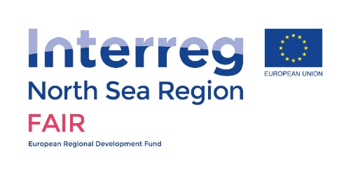Interreg FAIR

Task 3.1a Asset Management: Template Questionnaire

Hoogheemraadschap Schieland en de Krimpenerwaard

Project KIJK (D2016-08-000689)

Manon de Vries (August 31, 2016)

**3. Part B – Case study – Project KIJK**

**Question 3.1: Setting the scene of the case study**

***Name of the case study and a map***

Project KIJK is an abbreviation of Krachtige IJsseldijken Krimpenerwaard (i.e. powerfull IJssel dikes Krimpenerwaard). It is a flood protection project in the Dutch Flood Protection Program called HWBP. Project KIJK is situated within the catchment area of Schieland and the Krimpenerwaard (HHSK), a regional water authority in The Netherlands. HHSK lies partly below sea level. Without dikes this area would be uninhabitable; it would be flooded. The dikes of project KIJK, situated along the river Hollandse IJssel, are currently under investigation.

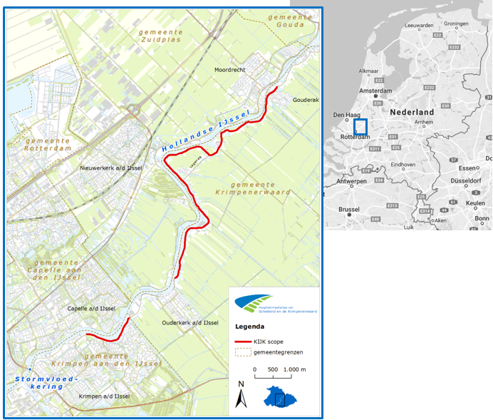

**Figure 1:** Project KIJK is situated along the east side of the river Hollandse IJssel between the cities of Rotterdam and Gouda, in the southwest of The Netherlands. The scope is 10,15 km.

***Focus/objective of the case***

The goal is to protect the citizens and economic values behind the dike against high water levels and flooding, and to meet the new Dutch safety standards. This will be carried out with acceptance of the local and regional authorities, inhabitants and other stakeholders. By using LCC (as is required by HWBP) the most effective way is determined.

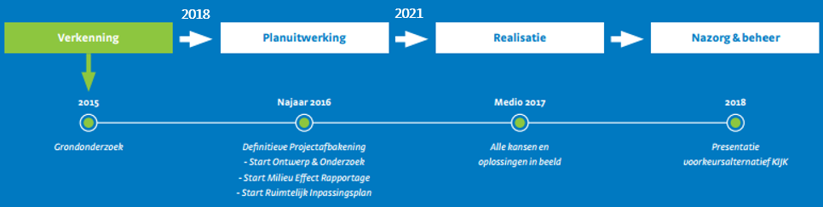

**Figure 2:** The four phases of project KIJK: exploration and design, planning and engineering, construction, control. The years in this figure are estimated.

***The physical setting***

*Nature and topography*

Project KIJK is situated just north of Rotterdam in a heavily populated area. The nearby natural areas are peat grassland areas and a so-called tidal forest that is frequently flooded with river water.

**Table 1:** The average groundlevel of the different objects in the project area of KIJK.

|  |  |
| --- | --- |
| Object | Meters below sea level (NAP) |
| Dike | 3 to 6 m (approximate average) |
| Land behind dike | 0 to -3 m (approximate average) |
| Water level Hollandse IJssel | -0,5 to -11 m (approximate average) |

*Sources of flooding*

The main source of flooding in this project is high water levels in the Hollandse IJssel, due to local wind storms, high river discharge after heavy precipitation, and tidal influences from the North Sea through the Nieuwe Maas. Climate change will worsen the effects of all the sources of flooding. Moreover, this area is affected by land subsidence (oxidation of peat), with an average rate of 1,1 cm/yr.

*Existing flood defence infrastructure*

The existing flood defence infrastructure is a dike with an asphalt road cover. On the dike itself and relatively close to the dike (on the landside slope as well as the riverside slope of the dike) are houses, offices, schools, monuments, hydraulic structures, and small harbours.

Just south of project KIJK at the mouth of the Hollandse IJssel a storm surge barrier called Stormvloedkering Hollandse IJssel was built in 1957, after the 1953 North Sea flood disaster. It was built together with the Algera Bridge.

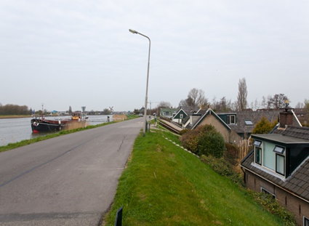 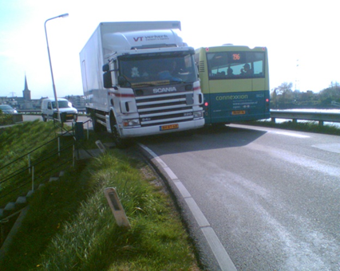

**Figure 3:** Two pictures of the dike along the Hollandse IJssel, that show the concentration of houses and heavy traffic.

***Socio-economic setting***

The area close to project KIJK is a semi-urban environment with 3 villages that are part of the two municipalities Krimpenerwaard and Krimpen aan den IJssel (see map in figure 1). The villages have become popular commuter towns for people working in Rotterdam, and have a combined resident number of about 37.000. The road on the dike is a major infrastructure service for cars, heavy traffic, recreational cyclists, school kids cyclists, and a bus line.

The dikes of project KIJK are part of dike ring area 15 in The Netherlands (see map in figure 4 below). This area has 200.000 inhabitants. A dike breach has a potential damage figure of about 1 billion euros and about 150 victims.

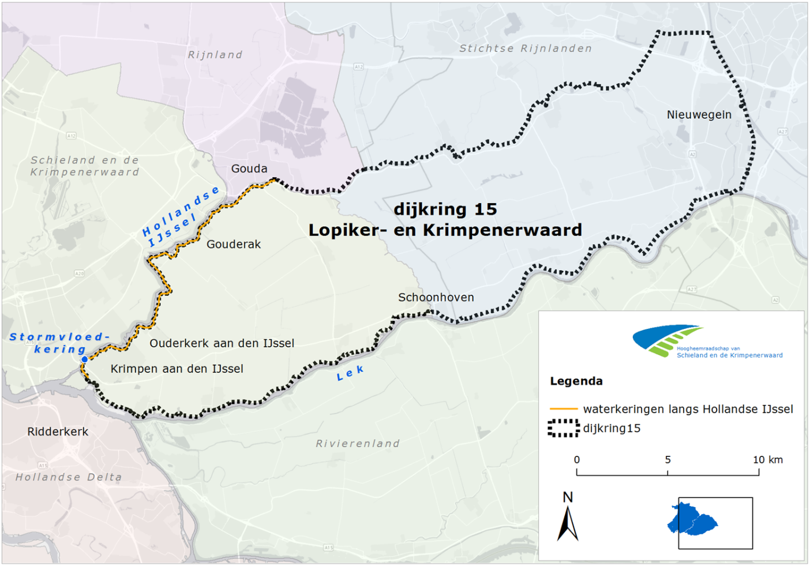

**Figure 4:** A map of dike ring area 15 with water authority Schieland and the Krimpenerwaard and surrounding water authorities. The dikes along the river Hollandse IJssel are displayed in orange.

***Have there been past floods in the area? If so, how was it caused and what impact did it have?***

In 1953 during the North Sea flood disaster the dike close to the village Ouderkerk aan den IJssel proved to be inadequate, resulting in a few deaths in Ouderkerk aan den IJssel and widespread property damage.

**Question 3.2: Specific challenges and barriers to be overcome**

**3.2a What is the asset management challenge**

Project KIJK is interested in gaining knowledge about the following:

1. LCC in Systems Engineering (system approach and LCC of the different functions in this system);
2. Maintenance costs index numbers of traditional and innovative solutions;
3. The use of (new for these kind of projects) LCC calculation or analysis tools, if available.

With respect to Systems Engineering, the idea of thinking in functions rather than objects and the whole system approach is adopted in project KIJK. With this, the ‘problem’ of project KIJK is not the object dike being insufficient, but what the project wants to address is the functional goal of protecting the citizens and economic values behind the dike against high water levels and flooding, and to meet the new Dutch safety standards. This could not only be solved with reinforcing the dike, but also with a combination of solutions in a broader perspective such as lowering water levels, optimizing the new safety standard of the Stormvloedkering Hollandse IJssel, minimizing the impact of a possible flooding, or using innovative solutions (see figure 5 below).

At the end of the exploration and design phase (‘verkenningsfase’) the preferred alternative (‘VKA’) will contain this combination of solutions per dike section. The challenge for project KIJK is comparing LCC numbers appropriately. For example, the lifetime (or service life) and the maintenance costs of the Stormvloedkering Hollandse IJssel asset is important for the preferred alternative of project KIJK. How do we compare the LCC numbers of this combination of solutions per dike section in project KIJK to other flood protection projects with dike reinforcement LCC numbers? How do we handle this in a practical manner?

Note to scientific partners: More information about this subject can be obtained if needed.

Adaptability and life cycle costing (LCC) are approaches that are part of project KIJK, since these approaches are the new standard in Dutch flood asset infrastructure. KIJK is working in close collaboration with the Dutch partners Rijkswaterstaat and Deltares, and the Hoogwaterbeschermingsprogramma (the Dutch flood protection programme).

The FAIR scientific partners can make use of the LCC approach in the design steps taken in project KIJK. Thus, next to what project KIJK can gain from FAIR, it can share with the FAIR partners.

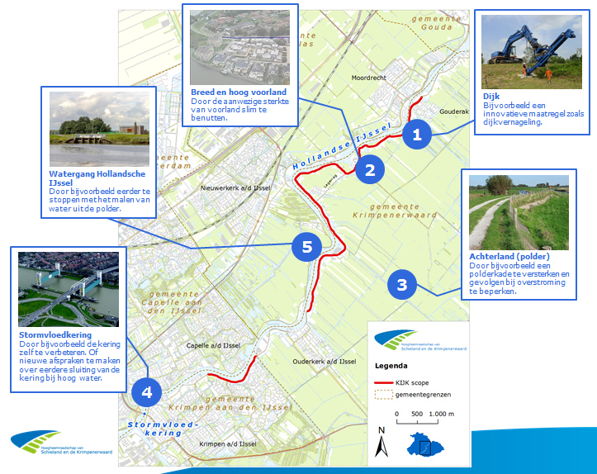

**Figure 5:** The whole system approach of finding solutions for the functional goal of project KIJK.

**3.2b Understanding of the current system**

***Physical understanding***

Accuracy and source of the floodplain topography data: TBD.

*What flood defence assets are important to the case study*

See table 2 below.

**Table 2:** Asset types to be considered in the pilot (asset typology after Sayers et al, 2015).

|  |  |  |  |  |
| --- | --- | --- | --- | --- |
| **Type of asset** | | **Example activities** | **Considered in pilot (yes/no)** | **Why?** |
| **Local scale infrastructure** | | |  |  |
| **Private homes and businesses** | Avoidance | Raising properties above flood levels (actively, floating homes, or passively, raised thresholds) or some other way to avoid flooding.  *\* What do you mean with raised thresholds?* | To be determined (TBD) |  |
| Resistance | The use of flood products and construction detailing to prevent water entering a property.  *\* Are self extracting barriers or ‘coupures’ examples here?* | TBD |  |
| Recovery | Use of building materials and practice that such that although flood water may enter the building no permanent damage is caused, structural integrity is maintained and drying, cleaning and minor repairs are facilitated. | TBD / not (yet) looked into |  |
| **Critical service nodes** | Avoidance | Raising critical functions / building above flood levels. Deployment of property scale ‘ring dykes’.  *\* Are construction walls at the water front at flood plains examples here?* | TBD |  |
| Resistance | The use of flood products and construction detailing to prevent water entering a property. | TBD |  |
| Recovery | The use of function specific building designs and network redundancy to avoid loss of function if flooded (i.e. continued power or communication distribution). | TBD |  |
| **System scale infrastructure** | | |  |  |
| ***Hard path infrastructure – Planning, design and management of built infrastructure*** | | |  |  |
| **Linear and network assets** | Active | Barriers that can be deployed as temporary and demountable defences. | TBD |  |
| Passive - Above ground | Raised defences and shore parallel structures (i.e. embankments, levee or dyke, breakwaters) through to storm water storage ponds. | TBD |  |
| Passive - Below ground | Individual pipes, CSO’s and the drainage network they compose. | TBD |  |
| **Point assets** | Active | Pumps, floodgates and sluices. | TBD |  |
| Passive | Fixed trash screen, groynes as well as interface assets (that link above and below ground linear systems) such as manholes and gullies. | TBD |  |
| ***Soft path infrastructure – Utilizing natural infrastructure systems*** | | |  |  |
| **Watercourse** | Channel | The management of vegetation (e.g. weed cutting) and sediment (e.g. shoal removal and dredging). | TBD |  |
| Floodplain | The management of floodplain roughness and debris recruitment. | TBD |  |
| **Coast** | Foreshore and backshore | The management of dunes and beaches through active (e.g. recycling and profiling) and passive (e.g. sand fencing, marram grass planting) management as well as natural wetlands and soft cliffs. | Not applicable here |  |
| **Urban landscape** | Urban land use | The engineering of urban green space, managing surface permeability (e.g. through SuDs) and debris recruitment. | TBD |  |
| **Rural catchment** | Rural land use | The management of rural run-off, sediment yields as and debris recruitment. | TBD |  |

*Note: FCERMi includes any feature that is actively managed to reduce the chance of flooding or erosion (Sayers et al., 2010). Dams and associated ancillary structures are excluded from this paper*

*Accuracy and source of information on asset geometry and their performance*

The national investigation of LRT3 in 2011 analysed the dike of project KIJK on two failure mechanisms (landward stability and height). The investigation of project KIJK focusses on 10,15 km, which consists of 2,10 km floodplain and 8,05 km dike. The 2,10 km floodplain will be further investigated by project ‘POV-Voorland’. The 8,05 km dike has been analysed in 2015/2016 in project KIJK; find the results in table 3 below. The new safety standard according to WBI2017 for project KIJK is 1/10.000 (‘signaleringsnorm’).

Note to scientific partners: More information about this subject can be obtained if needed.

**Table 3:** An overview of the potential failure mechanisms of project KIJK. The numbers are in meters, and are rounded.

|  |  |  |  |  |  |  |  |  |  |
| --- | --- | --- | --- | --- | --- | --- | --- | --- | --- |
|  | **Overloop en overslag** | **Opbarsten en piping** | **Macrostabiliteit binnenwaarts** | **Macrostabiliteit buitenwaarts** | **Stabiliteit Voorland** | **Microstabiliteit** | **Bekleding - Steenzettingen** | **Bekleding - Gras** | **Bekleding - Asfalt** |
| Onvoldoende [m]  Not sufficient | 7450 | 0 | 7650 | 5600 | 500 | 0 | 0 | 8050 | 0 |
| Voldoende [m]  Sufficient | 0 | 0 | 0 | 0 | 1050 | 0 | 0 | 0 | 8050 |
| Goed [m]  Good | 600 | 8050 | 400 | 2450 | 6500 | 0 | 8050 | 0 | 0 |
| Geen oordeel [m]  No result | 0 | 0 | 0 | 0 | 0 | 8050 | 0 | 0 | 0 |

***Socio-economic understanding (accuracy and source of information on floodplain usage)***

This is incorporated in the legal safety standard. For the determination of the safety standard national datasets are used.

***Existing plans and policies***

**Table 4:** An overview of the existing plans and policy influencing the approach to asset management in project KIJK.

|  |  |  |
| --- | --- | --- |
| **Policy or plan** | **Description** | **Influences on asset management at case study location** |
| **European policy** |  |  |
| Natura 2000 | ? |  |
| Eurocode | ? |  |
| **National policy** |  |  |
| Deltaprogramme – National level | ? |  |
| Bird habitat directive | ? |  |
| NNN – Nature Network in The Netherlands | Sets the requirement regarding connecting natural areas. | Near project KIJK NNN-areas are situated |
| **Regional strategies** |  |  |
| Deltaprogramme – region Rijnmond-Drechtsteden | Sets the regional requirements on the longer term | Less influence |
| **Local plans** |  |  |
| Zoning and land-use regulations / area development | Sets the requirements regarding local spatial planning | Upgrading methods for flood defence must meet national regulations |
| Traffic plan provided by province or municipality |  |  |
| Project 'Hollandsche IJssel, schoner, mooier' |  |  |
| Project ‘Aanpak Stormvloedkering’ |  |  |

**3.2c Future change**

***Climate***

Climate scenarios are incorporated in hydraulic conditions which are drafted by order of the Ministry of Infrastructure and Environment. These conditions are used to determine the design conditions.

***Socio-economics***

The socio-economic aspects (population growth) are incorporated in the legal safety standard.

**3.2d Governance and other aspects**

***Funding for development, maintenance, capital investment and security in the future***

Project KIJK is financed out of the ‘dike account’ (filled by the Ministry of Infrastructure and Environment, and all water boards on a 50/50 basis). The maintenance after is paid by the asset owner. At this moment the personal capacity of a single water authority is a bigger problem/issue than the funding stream in the future.

***How successful is asset management?***

If project KIJK does not meet the new standards it can be concluded that asset management has not been implemented successfully.

**Question 3.3: Overview of tools and data to be used (where this is known)**

**3.3a Reliability**

***Overview***

TBD. The analysis will be done by an external specialist engineer.

***Specific challenges and gaps in understanding***

TBD

**2.3b Deterioration**

***Overview***

TBD

***Specific challenges and gaps in understanding***

TBD

**Question 3.4: Decision process**

**3.4a Social justice**

TBD

**3.4b Robustness under conditions of future change**

In the Netherlands the climate scenario is prescribed and hereby the climate change to be accounted for. The floodplain and the uncertainty is not (yet) incorporated in the legal safety level.

**3.4c Investment planning**

There are no funding constraints since the necessary budget has been programmed. After completion of project KIJK the maintenance (specific for this case) will we taken over by regional water authority Schieland and the Krimpenerwaard (HHSK).

**Question 3.5: The relationship of asset management to board planning issues**

The available budget is used for upgrading the flood defence to the legal safety level. There are initiatives in multi-benefits (meekoppelkansen) and the initiator is responsible for the necessary additional funding. For project KIJK the initiatives are related to road traffic safety and sustainability.