Meet the Buyer event
Online one-on-one meetings possible on t.b.d. dates
Senefelder-Ring 45, 21465 Reinbek (Germany)



TIMM is an SME company established in 1963, specializing in security technology for industrial application with a focus on the (petro)chemical and renewables industries.

To take IntelliLock, our core product for the wind industry, to the next level we are looking for a partner who is experienced in (programming of) web-based access control solutions.

Buyer profile

What is their business?

Since 1963, TIMM has been active in the field of industrial security technology with a focus on the (petro)chemical industry. In 2017, we started our journey to renewables by developing IntelliLock, the smart access control system for wind turbines. IntelliLock helps wind farm operators to reach three goals: 1) Enhance wind turbine security; 2) Manage operator responsibilities; and 3) Streamline and digitalize operational processes.

IntelliLock consists of hardware, which is installed in the wind turbine, and software. The IntelliLock software is currently hosted on a server of the wind farm operator (on premise). Communication runs via existing networks. For more information visit www.intellilock.de/en .

What are they looking for?

Now, we want to take IntelliLock to the next level by
- Moving the IntelliLock software to the cloud
- Becoming independent of existing wind farm communication networks.
To reach this goal, we are looking for a partner. Our ideal partner is a software company with a track record in programming web-based access control and monitoring solutions. Moreover, the ideal partner would
- already have a web-based platform for access control into which we could integrate IntelliLock
- be familiar with IT security requirements, e.g. according to ISO 27001.

How can you apply?

If you are interested in this opportunity, please contact Martina Christiansen by sending an email to m.christiansen@ee-sh.de and briefly indicate the interest of your company in the Buyer’s case. You can also contact your regional SCALE-UP partner.

The deadline to apply is Friday, January 15th, 2021
SCALE-UP PARTNERS
This Meet the Buyer event is an exclusive invitation for companies associated with the partner organisations in the North Sea region. Cleantech member organisations have joined forces in the Interreg SCALE-UP project to enable cross-border business contacts between SMEs with green solutions and established large companies. The overall aim is to facilitate for innovative cleantech companies to scale up your start-up. Consultants at the member organisations help participants prepare the meetings and support them through the business process.

CONTACT
BELGIUM  Cleantech Flanders  Frans Snijkers  frans.snijkers@cleantechflanders.com  Tel +32 473 34 12 16 | DENMARK  CLEAN  Maria Skotte  mas@cleancluster.dk  Tel +45 6142 4400
NETHERLANDS  Clean Tech Delta  Giuliana Unger  g.unger@cleantechdelta.nl  Tel +31 108 20 88 29 | SWEDEN  RISE Research Institute & Cleantech Inn Sweden  Richard Englund  richard.englund@ri.se  Tel +46 703 791 645
UNITED KINGDOM  Cambridge Cleantech  Sam Goodall  sam.goodall@cambridgecleantech.org.uk  Tel +44 7782271066 | GERMANY  EE.SH  Martina Christiansen  m.christiansen@ee-sh.de  Tel +49 4841 6685 27
SCALE-UP COORDINATION
City of Rotterdam
Wouter van Rooijen
w.vanrooijen@rotterdam.nl
Tel +31 6 15 25 1699

 |  | 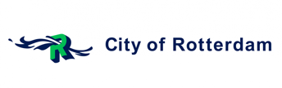 | 
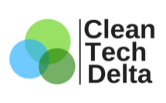 | 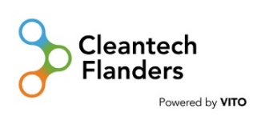 | 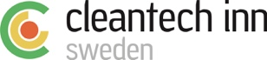 | 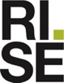 | 