**Location**: [ÅBYGGET](https://www.google.com/maps/place/%C3%85BYGGET,+HYLTEBERG,+310+83+Unnaryd/@56.9866283,13.5376528,17z/data=!3m1!4b1!4m5!3m4!1s0x4650fcb086b51f95:0xbe4a47763eb09ef0!8m2!3d56.9866283!4d13.5398415?hl=sv-SE), HYLTEBERG, 310 83 Unnaryd (Sweden)

**Wednesday, 22 September 2021 and Thursday, 23 September**

Present (15 persons):

Dennis Sieperda, Albert Ruiter and Brigitte Feenstra - Province of Fryslân, Peter Joore - NHL Stenden, Sybrith Tiekstra and Janneke Stuive-Stelpstra – IPF, Erik Ruth – Nordic Surfers, Lieselotte van Tomme (online) – HOWEST, Carla Smink – Aalborg University, Peter Uppman and Tobias Tisell - Region Halland, Quynh Phuong and Thomas Baron - LEMEX

Guests: Thor Axelsson, Hans Wevers (online)

**Announcements Lead Partner**

* report 5: This full report has been send in yesterday. Report 6: This report (hopefully basic) will open after report 5 has been approved with Viborg. See the steering group minutes for an overview.
* The Lead Partner had a meeting with Christian Byrith and Hans Wevers of the JTS last Monday. Question: Do you have enough money for the whole year of 2022?
* Partners: Rasmus and Lieselotte are both ill and not joining this meeting physically. However, Lieselotte will be online from Gothenburg and Rasmus will join online later. André has a new job in Switzerland and because of COVID he had to stop organising M01N start up Camp.
* After this partner meeting we will provide all attendances’ with a COVID test, so you can test yourself after you returned home.
* Because Anne Pintz is on maternity leave, we have a new temporary Interreg NSR contact point: Hans Wevers. He joined us online the first part of this meeting, so Hans was able to introduce himself. Welcome!

The winner of the last Inno-Quarter challenge, Sybrith Tiekstra, made a new challenge: The Inno-Quarter Bingo. This Bingo was quite an distraction this morning, but that came to an end when Carla ticked all the boxes. Congratulations Carla!

**Festival season 2021**

The Netherlands, Dennis Sieperda and Janneke Stuive-Stelpstra.

|  |  |  |
| --- | --- | --- |
| Oerol Test event |  | Unfortunately the Amsterdam Dance Event has been cancelled. This is a pity, because we had a workshop planned there to launch the Festival Experimentation Guide.  In June 2021 Inno-Quarter took part in an online Oerol test event together with Innofest. |
| DORP: The feedback tear sheet worked really well. |  | Unfortunately Welcome to the Village was cancelled. DORP wasn’t, but was an indoor event this year in Leeuwarden. Because of a COVID incident DORP ended a few days earlier as planned. Which was a pity, because it felt like a real festival. |

Germany, Thomas Baron

M01N startup Camp was cancelled. On 25 November Prototype Party Zukunft will be organised.

The University of Bremen organised *Open Campus* (online, 7 June 2021)

The learnings of a pure digital Inno-Quarter: One main event instead of several side events, the duration of the session & number of agenda points, the amount of participants per room and it was more difficult to keep the interaction running.

|  |  |
| --- | --- |
| *Sustainability Day* on the market square of Bremen  (24 July 2021).  Key learnings of an Inno-Quarter without festival attachment:   * Need to explain Inno-Quarter approach Mobile advertiser Teams regular smaller space at the same spot * Food Startups vs. physical prototype * Cooperation with regional start-up programs |  |

Belgium, Lieselotte Vantomme (online)

Some events were allowed under strict rules. However HOWEST took no part in Dranuter, Crammerrock and also Howestival was cancelled just before the start.

Student Welcome, on 7 October is for 2000 students. This is a Summer school with no workshops. The Start-ups Ecortho, Join and Tropaholic will test during this Student Welcome.

Sweden, Tobias Tisell

Silicon Halli had a different set-up each year because of Covid. 9 Start-ups were able to test, 28 Start-ups applied.

|  |  |
| --- | --- |
|  |  |

|  |  |
| --- | --- |
|  | *Into the Woods*, Erik Ruth  With Into the Woods we started from scratch. There was no infrastructure on the location. Due to Corona we needed to downsize the festival. Now, after the first festival we can take it one step further. For our festival it is key to find the best offgrid solutions, and we are focussing on the question which problems do we need to solve first? |

Research, Sybrith Tiekstra

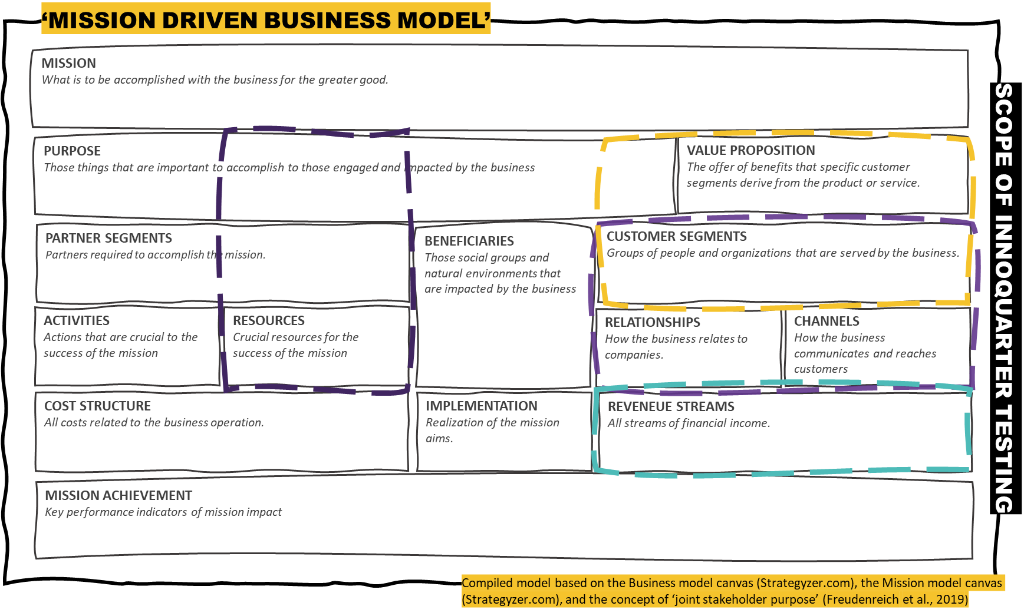

Sybrith will interview the start-ups to finish the research. Because a lot of festivals were cancelled it is difficult for her to get the right amount of data.

Research, Quynh Phuong

LEMEX is on schedule. This year we could do 13 interviews for our research at 2 festivals. The primary research topics are Role of Living Labs, Feedback Processing, Entrepreneurial Learning, Virtual Context and Regional Capacity building.

There will be an article in the *Austrian Management Review* (vol. 11) were IQ and the concept of IQ as a Living Lab will be introduced, further different approaches and different stages of IQ en prerequisites will be explained. The next step is to focus on group interviews.

The final report will contain the IQ approach as applicable scientific framework, the potential of the IQ approach for regional innovation support, requirements for a successful adoption of the IQ mechanism into a regional start-up support infrastructure and recommendations on the regional applicability and standardization of the IQ-elements.

During the meetings, lunch or dinner was being prepared by chef Victor.

|  |  |
| --- | --- |
|  |  |

**Future projects**

|  |  |
| --- | --- |
| Regenerative festival design, ecosystems  Use festivals as an instrument.  If you look to the festival:  - students want to learn  - business want to earn money,  - employability,  - people/guests ‘what’s in it for me?’  - government is about policy  How do you look at it?  What can Europe learn from countries which do not have the European infrastructure? | Regenerative Festival Lab :This cooker was invented for remote areas not for festivals |

**Summary discussions Future projects**

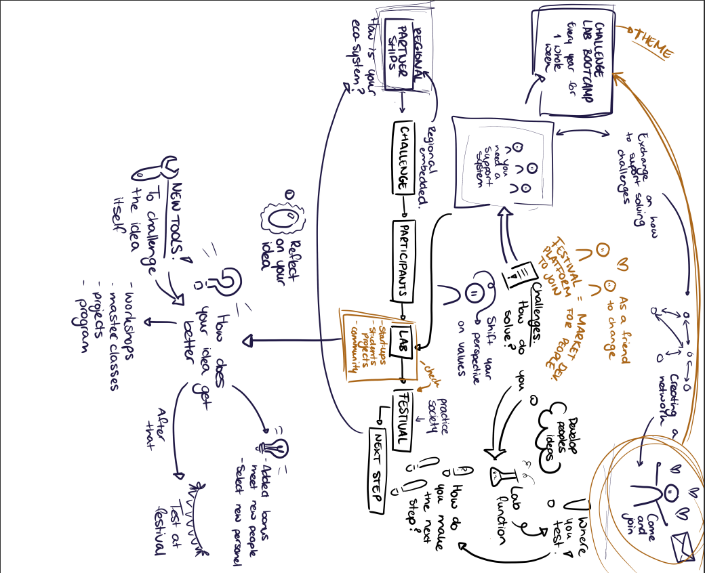

**Klimafolketmodet (Denmark)**

1 to 3 September 2021

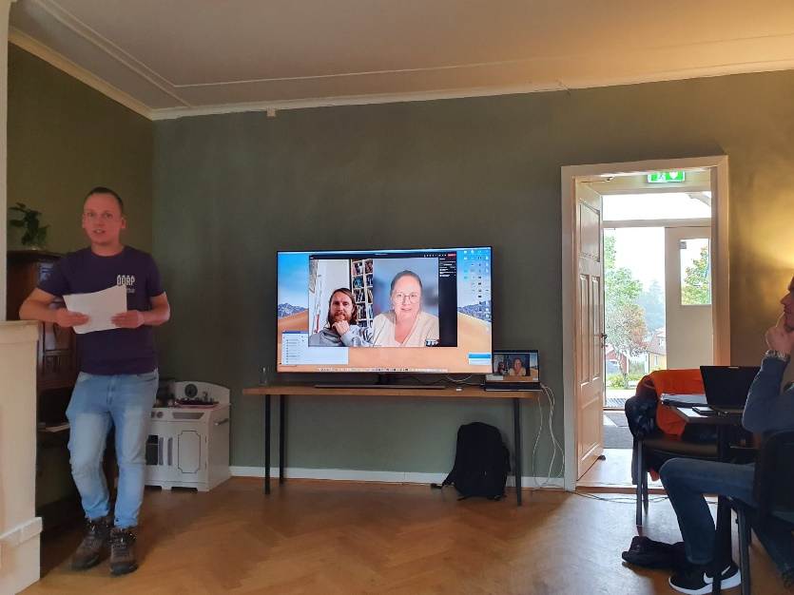Rasmus of Worldperfect is online and informs partners about the workshop during the [Klimafolkemodet.](https://klimafolkemoedet.dk/) (1 to 3 September 2021)

The Viable growth model works really well also in schools. For this workshop Worldperfect used the Festival Experimentation Guide (NHL Stenden).

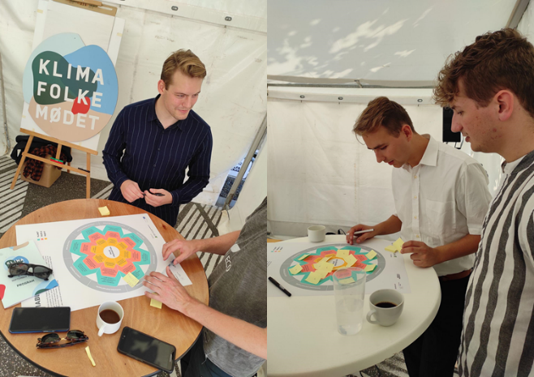

The startups Underflod and Harmoniq Audio took part in the festival. After preparing and following the workshop, the start-ups presented their challenges to an audience.

**Steeringgroup meeting**

For the content of the steeringgroup meeting partners can have a look at the steeringgroup minutes.

**Some more impressions of the partner meeting**

|  |  |
| --- | --- |
| Visit from the mayor of Hylte Kummun, Mr Ronny Lofquist  A big project for Hylte Kommun is looking for owners of deserted houses in the area. | And of course a very special thanks to our Swedish chef Victor |
| Guided walk through the forrest: Forrestbading. |