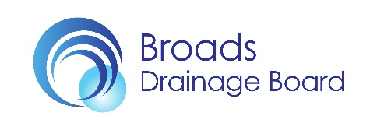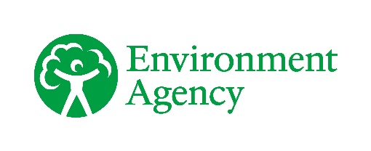



Frequently Asked Questions

Horsey Water Filtration and Wet Farming Demonstration

**What is happening at the Horsey wet farming demonstration site?**

* The Broads Authority, Broads Internal Drainage Board, Environment Agency and the Horsey Estate are testing water cleaning and wet farming and in doing so we are engaging with farmers, land managers, policy makers about its merits, and what is required to create and extend this new wet farming system in the Broads. It is a trial for Water Filtration and Wet Farming, also known as Paludiculture.
* Paludiculture is not well known and currently there is no specific agri-environment scheme support yet. It is essential that landowners are willing to find out about paludiculture, and partners have no means to requisition certain sites for it, so it is essential to test and engage. The main objective of the project at Horsey is to engage with people about constructed wetlands to clean water and paludiculture.
* There are many barriers to changing well established farming systems with known and trusted funding sources. The demonstration site has allowed us to generate excellent engagement to show the proof of concept to interested landowners.
* For more information on the Horsey site, [please see our videos here,](https://www.youtube.com/watch?v=DJ0XmcwP7wc)and [here](https://northsearegion.eu/canape/news/canape-chats-episode-3-wetland-farming-at-horsey/) . You can find out an earlier [progress update here](https://northsearegion.eu/canape/news/canape-progress-at-horsey-wet-farming-trial/), or read our [information sheet here](https://northsearegion.eu/media/20415/horsey-wetland-project-factsheet-feb-22.pdf). Photos and the site plan are below in Annex 1 and Annex 2.
* The one-year trial in 2022, bearing in mind the summer heat wave, was not long enough to test natural reed recolonization, although we are seeing excellent reed growth in some areas of the trial. Partners are seeking additional funding to continue the project post 2022.

**Why was the site at Horsey chosen?**

* There is a willing and engaged landowner, ready to test a completely new farming system on his land. This is a key criteria for any paludiculture project. It is acknowledged that there may be better sites elsewhere, but so far, landowners have not been willing to collaborate.
* The location is ideal to filter out some of the ochre pollution that flows into Horsey Mere, a nationally and international designated nature reserve. At Horsey, we can also assess other water quality benefits of the wetland.
* The site has easy access for people to visit, with space to park cars and minibuses. This is important because the main purpose of the trial is engagement about water filtration and this new type of farming. In 2022, project partners have held over 15 local, national and international meetings and educational tours.
* There is a public footpath with excellent views across the site. This helps to explain the project to visitors. We have also created an interpretation panel for people using the footpath.
* It is easy to control water levels of the drained marshes on this site, which means that water levels and flow can be varied with gravity and pumping as required. This would be a challenge for reedbed connected to the rivers which are increasingly affected by rising sea levels.

**What is the engineering design at Horsey?**

* The land was levelled and under 50% of the site turf stripped and this material used to create earth bunds to retain water within the demonstration area and prevent water flowing in the surrounding field ditches, (see Annex I – Site Schematics).
* The demonstration sites ‘irrigation’ water comes from Waxham cut and enters the site via a manually controlled gravity-fed inflow.
* The water flows through pipes that connect each of the five compartments and exits into the lower level pumped drainage system.
* The compartments are designed to hold a maximum of 20cm of water. Elbow turns on the pipes that connect each compartment can be changed to hold different water levels.

**What is required for larger areas of the Broads to become wet farming lands?**

* Paludiculture is in the development and engagement phase. It is a new form of agriculture. The government’s Lowland Agricultural Peatland Task Force Road Map prioritises engagement and exploration over the next 2 years (2023-2024), including via demonstration sites. To do this, a network of demonstration sites is required by early adopters.
* The Government demonstrates their commitment to wetland farming demonstration by incentivising further engagement with the launch of a 2 year £5 million ‘[Paludiculture Exploration Fund’](https://www.find-government-grants.service.gov.uk/grants/nature-for-climate-paludiculture-exploration-fund) in January 2023. We want to try and keep Horsey as a demonstration site because of the expected future importance of constructed wetlands and paludiculture for the Broads, particularly given the investment and progress made so far.
* Establishing reed and other wetland plants and the corresponding filtration and farming system is not simple or quick and there is much to learn and discuss. For example, changing to organic farming or regenerative farming can take five years before the soil ecosystem begins to change. The project set out to learn the best techniques for planting, seeding, water control, grazing protection and water cleaning. This learning will inform future potential projects, with evidence to support applications for external funding, it will also inform future water policy, as well as lessons learnt to improve propagation methods for further trials. The learning continues at this site, for example we will test a spring planting phase, patch planting, water flow management and cultivating from novel [CEEDS](https://www.newenergyfarms.com/) need testing.

**Have you worked with reed growers and reedcutters and who might benefit in the long run?**

* The project has engaged with the Broads Reed and Sedge Cutters Association (BRASCA) and the British Reed Growers Association (BRGA) with updates given at each of their meetings, and their members attended regular site visits to Horsey throughout the project.
* Funded by the Broads Authority, BRASCA have worked with landowners, to assess the potential to expand the reedcutting industry in the Broads. These conversations continue, however opportunities for expansion of existing reedbed are limited due to water level constraints and the mosaic of conservation management. For example, despite Bygraves Marsh at Hickling succeeding to grow reed from the initial grassland, cutters are not yet satisfied with the reed quality, and NWT find it increasingly difficult to control water levels which are linked to the river, with higher winter levels, making reed cutting challenging. Finding suitable sites for growing reed for commercial cutting is not straightforward.

**Why is there some fencing around the Horsey site?**

* The fencing is temporary. It is necessary to exclude deer from the site, who like to graze on young plants.
* Fencing is commonly used in forestry to protect young trees against deer grazing. Tree replanting is also often required if they are grazed or do not take in their first year. This wetland planting set up is no different.
* Consulting with wetland experts, it is expected that the fencing can be removed as reeds grow beyond 90cm. This is possible within one year if the initial establishment is effective, but may take longer.
* Feral greylag geese are mobile and present in each river valley of the Broads, and also like to graze on young reed shoots. All sites in the Broads are accessible to geese who particularly enjoy quiet nature reserves such as Martham, Hickling and Hoveton where they are not disturbed by shooting for example. The fencing has been modified to also exclude the presence of flightless geese present in May-June.
* Reed establishment has been slow at Horsey, which is similar to other recently reed planted sites, such as NWT Hickling and Potter Heigham, because of geese grazing.
* We expect a full reed water filtration and possible harvest of a biomass crop to be ready in 3-4 years with the correct cultivation methods and water management.

**Can private finance pay for lowland peatland restoration?**

* Some private funding could come in the form of carbon credits. A lowland Peatland carbon code is developing which will explain which sites could be eligible, and how to calculate the carbon credits. The eligibility criteria carbon finance for upland bogs have been published in the [UK Peatland Code](https://www.iucn-uk-peatlandprogramme.org/sites/default/files/header-images/Peatland%20Code/Peatland%20Code%20v1.2.%202022.pdf) and they require that a site has a peat depth of over 50cm across 75% of the survey points on the site (there can be multiple sites within one landholding), and that the site meets the additionality requirements of the UK Peatland Code.
* Across all peat habitats, sites that are restoring peat from a degraded condition to an improved condition will generate more carbon credits (and potential revenue) compared to a site where the peat is already in good condition.
* Currently we are unable to say with certainty whether paludiculture will be allowed or not within the lowland Peatland Code.
* Other forms of private finance can be available. For example, developers will need to look for Biodiversity Net Gain to compensate for the biodiversity loss from the development. In some areas, nutrient credits are also required to compensate for the impact of phosphorus and nitrogen on water quality. The site at Horsey could be eligible for Nutrient Neutrality investment, subject to future development in the area. Water companies could also be interested to fund investment in wet farming as a way to improve water quality.

**Is anyone trying paludiculture in other parts of the UK and Europe?**

* The Broads Authority’s [CANAPE](https://northsearegion.eu/canape/paludiculture/) project partnered with four other countries (Netherlands, Germany, Denmark and Belgium) to trial paludiculture.
* Other paludiculture examples are found in the ‘Useful links’ below. It includes the [WaterWorks](https://www.greatfen.org.uk/water-works) project in Cambridgeshire and [Paludi-PRIMA](https://www.moorwissen.de/cultivation-of-cattail.html) 10 ha bunded site in Germany (see photos below).

**Mature Plants used to start the Typha crop, Paludi – PRIMA, first season**

©**S. Wichmann**

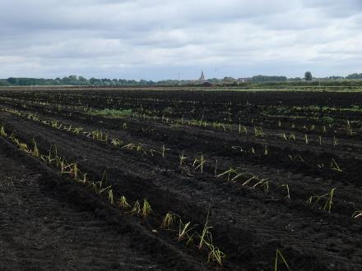 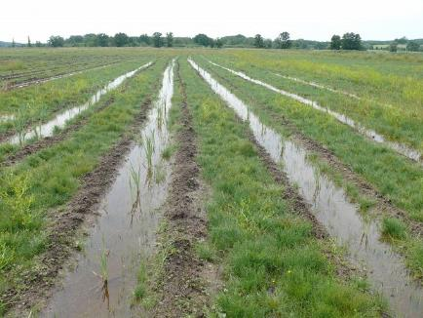

**Do these crops remove nutrient from the water and are the nutrient levels in the water at Horsey too high for commercial reed growth?**

* Water quality formed part of the options appraisal to identify the location, to treat the water and improve its quality by lowering its nutrient levels before entering Horsey Mere and the SSSI.
* Common reed and reedmace (Typha) planted at Horsey have a large nutrient removal capacity. They can reduce concentrations of phosphates and nitrates from the irrigation water, passing cleaner water on downstream.
* Paludiculture crops require nutrient to achieve good harvest. Reed and Typha that do not receive enough nutrient would provide a poor harvest.
* At Horsey, generally the nitrogen levels are high, while the phosphorus levels are low. Table 1 compares the Horsey values to other broads.
* Phosphorus levels in Hickling Broad, the rivers Bure, Yare and Waveney are higher than those in Horsey Mere, with commercial quality reed grows in all these places. Levels of nitrogen are broadly similar in Hickling and Horsey Mere.

**Table 1 showing the range of values at Horsey and comparison with water quality standards and status of other broads.**

|  |  |  |  |
| --- | --- | --- | --- |
|  | **Range of values monitored in Horsey wet farming demonstration** | **Water quality standard required to Pass Natura 2000 Protected Area** Special Areas of Conservation (SACs)* Common Standards Monitoring for Freshwater Lakes Version March 2015** | **Status of other broads** |
| **Total Phosphorus** | <20ug/l (below the laboratory limit of detection) | 30ug/l * | Hickling Fail  Horsey Fail  Martham Fail  Barton Fail  HGB Fail |
| **Total Nitrogen** | 7-15mg/l | 1.5mg/l ** | Hickling Fail  Horsey Fail  Martham No monitoring data  Barton Fail  HGB Fail |

**Is the Horsey wet farming demonstration site creating methane emissions?**

* Methane is emitted naturally from wetlands and waterbodies, such as reedbeds, ditches, lakes and rivers. When water is held at or above the surface during the warmer summer months, bacteria break down organic compounds into methane gas.
* In 2022 Cranfield University calculated methane flux from the simulated average annual effective water table depth for areas of the Broads using the regression equations from Evans et al. (2021). The calculated methane flux (tC/ha/yr) from peat soils for areas with high or over surface water tables were 1.5 tC/ha/yr. This compares to over 5 tC/ha/yr for CO2 flux for drained peat areas. Thus, it is beneficial to rewet grassland peatlands in terms of overall emissions reductions.
* The Horsey site has a dual purpose of cleaning water, via a flow through constructed wetland, and raising the water table to grow wetland crops. If wetland crops were being produced with the sole purpose of reducing emissions is would be preferable to retain water levels at 10-30cm below the soil surface.
* We are informed by the Centre for Ecology and Hydrology about research to show that saline water lowers methane emissions on wetlands.

**What is the impact of increased salination on peat restoration and on carbon emissions?**

* The impact of saline/brackish water on a site will have to be assessed on a case-by-case basis, depending on the location of the site and the vegetation on site.
* Common reed and lesser reedmace grow in brackish water around Horsey and in other brackish areas of the Broads. This will be further tested during the 2023 planting trial.
* As stated above, we are informed by the Centre for Ecology and Hydrology about research to show that saline water lowers methane emissions on wetlands which is beneficial for climate mitigation.

**Currently, farmers can borrow money against the value of the land or the activities on it. Will this borrowing capacity be reduced if the land is taken out of dry farming production for paludiculture?**

* The land use change, taking land out of dry farming production, will only be applied on the defined restoration site area, any other commercial activities can continue to operate adjacent to the defined restoration area. Further, the UK government is supporting specific financing options for restoration (see for example the [Big Nature Impact Fund](https://www.gov.uk/government/news/update-on-the-big-nature-impact-fund), a public-private blended finance vehicle).

**What is the project timescale at Horsey and what monitoring will be done?**

* The project is expected to be continue until early 2025 and partners will be looking for funding to make it happen. 12 months of data has already been collected in 2022.
* The monitoring include data on the establishment of the plants, ochre and nutrient levels when water comes into the site, and when it leaves the site, water levels, biomass quality of the crops, and records of all expenditure.
* The pilot site will also provide practical information on the technical details for implementation, plant growth, and costs of wetland plant cultivation.
* Multiparameter sonde data was taken on each monitoring visit to site, focusing on taking approximately 50 measurements per sample and sampling all compartments, the river and all surrounding dykes. The parameters measured were conductivity, pH, turbidity, Dissolved oxygen (% and concentration) and salinity.

**What is the strategic context for this project?**

* The [Broads Plan (2022-27)](https://www.broads-authority.gov.uk/about-us/how-we-work/strategy/broads-plan-2022) sets out aims for reducing emission from peatland soils, of which there are 2,500ha of peat grazing marsh in the Broads. Water tables need to raise to rewet the peat and reduce the emissions from peatlands.
* A key action listed in the Broads Plan is to create reedbed/fen and protect peatlands (under priority action B3).
* The project aims to: improve water quality (ochre and nutrient removal– monitored by recording of inflow and outflow samples): improve biodiversity; prevent carbon emissions (climate change mitigation); and produce crops .
* The project aligns with a number of strategic documents: Environment Act 2021, 30 by 30 commitments, Norfolk And Suffolk Nature Recovery Strategy, Norfolk Rural Economic Strategy.
* Carbon credit and nutrient credits (private income streams) are mechanisms investigated to fund peatland restoration. The economic viability of potential projects is assessed through the [Revere](https://revere.eco/) initiative.

**What are the next steps?**

* We will be testing a new planting regime in 2023, including testing novel [CEEDS](https://www.newenergyfarms.com/) and planting saline tolerant reedmace to investigate how they perform.
* The [Broads Peat NCPGS Discovery project](https://www.broads-authority.gov.uk/looking-after/projects/nature-for-climate-peatland-grant-scheme-discovery-grant) (2021-2023) is investigating the feasibility of peatland restoration across 15 sites in the Broads.
* We will continue to engage widely about paludiculture through events & site visits.

**Did you have to consider protected species and water voles?**

* Yes. Water vole and other protected species legislation and mitigation was followed and put in place before and during construction. For the Horsey wet farming demonstration site, there is no impact on water voles, as there is no change in the water level in the surrounding ditches which are not connected to the wetland area.

**Who have you been advised by?**

* Project Board: Broads Authority, Broads IDB, Environment Agency, Horsey Estate
* CANAPE EU project partners <https://northsearegion.eu/canape/partners/>
* [RM Wetlands & Environment Ltd](http://www.rmwe.co.uk/about-us/)
* [Exo-Environmental](https://www.exo-env.co.uk/)
* [verdant solutions Ltd](http://www.verdantsolutions.ltd.uk/)
* New Energy Harvest [CEEDS](https://www.newenergyfarms.com/)
* [Wetlands Products](https://www.wetlandproducts.com/)
* Palladium [Revere](https://revere.eco/)
* Natural England

**Useful Links**

* Farming Today - 08/02/23 Rewetting peatlands - BBC Sounds <https://www.bbc.co.uk/sounds/play/m001hwy9>
* For more information on the Horsey site, [please see our videos here,](https://www.youtube.com/watch?v=DJ0XmcwP7wc)and [here](https://northsearegion.eu/canape/news/canape-chats-episode-3-wetland-farming-at-horsey/).
* March 2022 blog is available as a [progress update here](https://northsearegion.eu/canape/news/canape-progress-at-horsey-wet-farming-trial/)
* The interpretation available on site [information sheet here](https://northsearegion.eu/media/20415/horsey-wetland-project-factsheet-feb-22.pdf)
* Sister project in the Fens [Wet Farming (fensforthefuture.org.uk)](https://fensforthefuture.org.uk/creating-the-future/wet-farming)
* CANAPE website about paludiculture [Paludiculture, Interreg VB North Sea Region Programme](https://northsearegion.eu/canape/paludiculture/)
* Interesting case studies [Projects – Wetland Products](https://www.wetlandproducts.com/projects/)
* A paludiculture newsletter [Paludiculture Newsletter - Greifswald Mire Centre (greifswaldmoor.de)](https://www.greifswaldmoor.de/paludiculture-newsletter.html)
* A German project about paludiculture on degraded fen sites [Prima - Moorwissen en](https://www.moorwissen.de/prima-en.html)
* Peatland Code information - [Peatland Code v1.2_3.pdf (iucn-uk-peatlandprogramme.org)](https://www.iucn-uk-peatlandprogramme.org/sites/default/files/2022-05/Peatland%20Code%20v1.2_3.pdf)
* Registry of peatland projects under the UKPC - [Markit Environmental Registry - Public Reports](https://mer.markit.com/br-reg/public/index.jsp?entity=project&sort=project_name&dir=ASC&start=0&acronym=PC&limit=15&additionalCertificationId=&categoryId=100000000000001&name=&standardId=100000000000157)
* Information on stacking and bundling - [STACKING & BUNDLING (cdn-website.com)](https://irp.cdn-website.com/82b242bb/files/uploaded/Background%20Paper%20Stacking%20and%20Bundling%20Wo-0001.pdf)
* Information on buying carbon units - [202206_IUCN Briefing Document_03 Buying carbon units ONLINE_0.pdf (iucn-uk-peatlandprogramme.org)](https://www.iucn-uk-peatlandprogramme.org/sites/default/files/2022-07/202206_IUCN%20Briefing%20Document_03%20Buying%20carbon%20units%20ONLINE_0.pdf)

**References**

* Evans CD, Peacock M, Baird AJ et al. (2021). Overriding water table control on managed peatland greenhouse gas emissions. Nature 593, 548-552. Doi: 10.1038/s41586-021-03523-1
* Holman I, Girkin N, Truckell I (in preparation) Estimating emissions from peat soils in the Broads. Report to the Broads Authority

# Annex I – Site Schematics

# A diagram of the site

# Annex II – Selected construction pictures

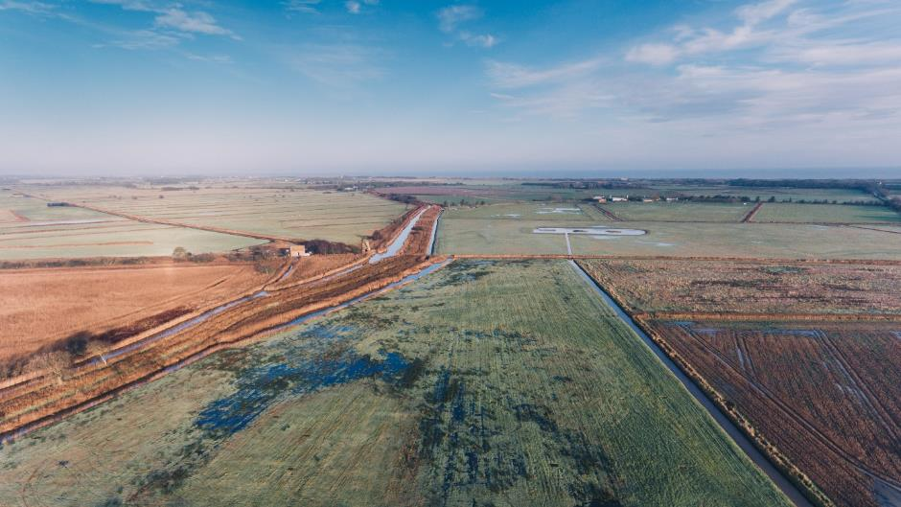

2021: Initial condition - grassland – a farming area with marginal earnings

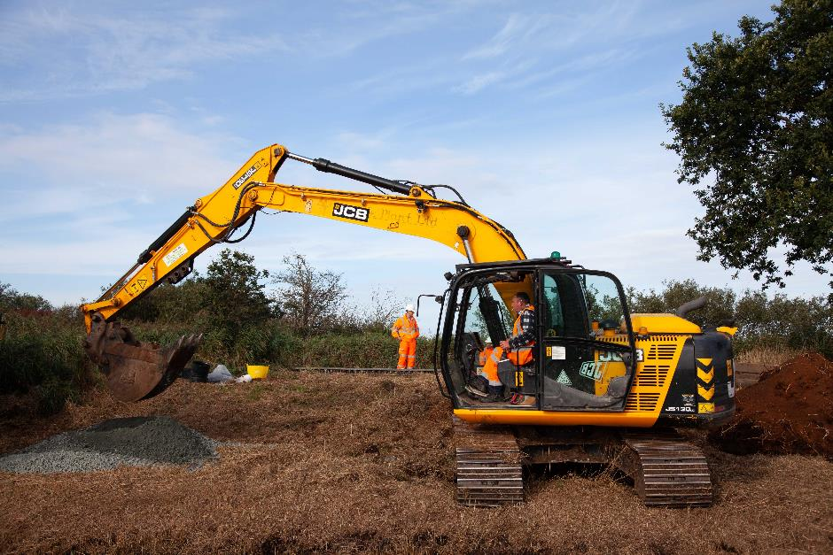

2021: Installing the water inlet

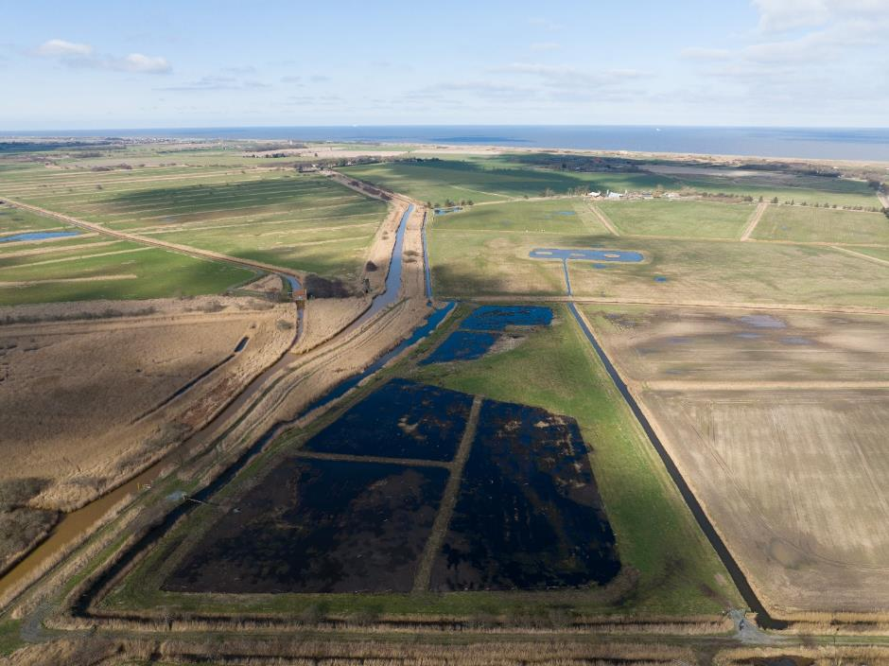

2022: Following construction

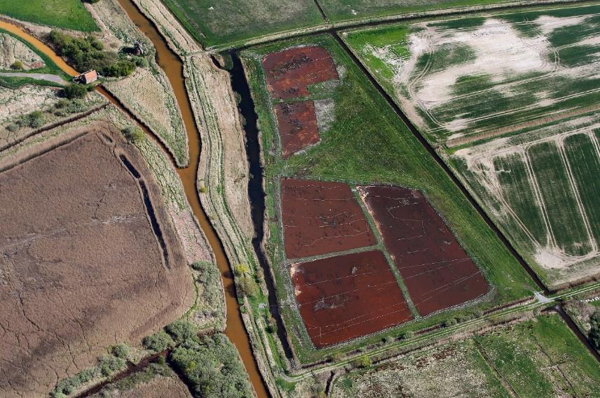

2022: Filtering ochre, see the red deposits (Mike Page)

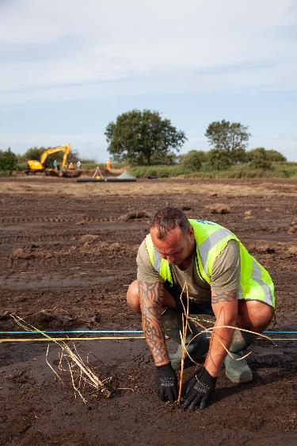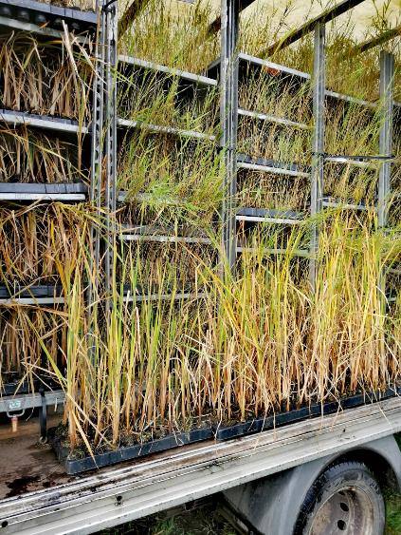

2021: Planting plug plants

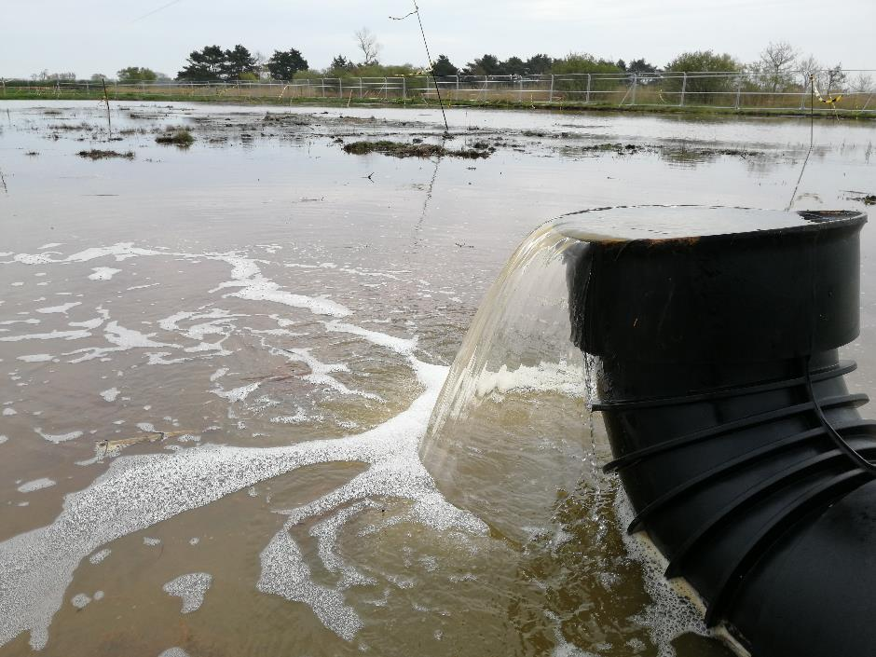

2021: Water inlet

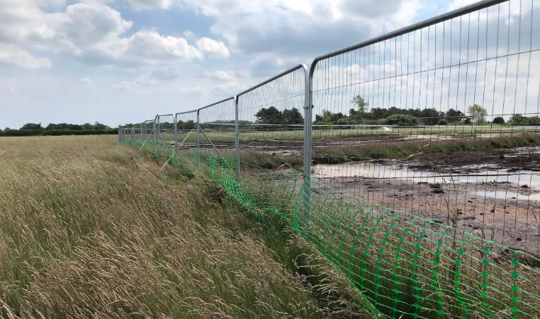

2022: Temporary barrier fencing

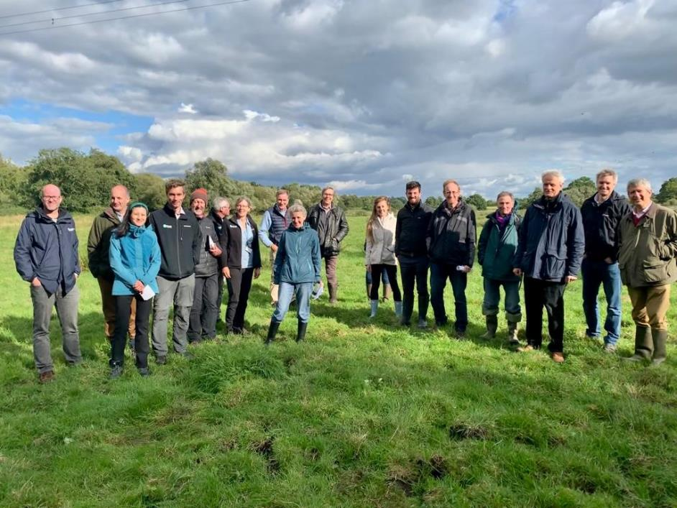

2021: On of the engagement site visit by the UK Lowland Agricultural Peatland Task Force. There have been a further 15 engagement events held at the site in 2022.