**Your Pocket Guide to Sustainable Peatland Farming**

**A vision for the future of wetland farming that:**

Protects farmers livelihoods, our climate and our biodiversity

**What is this guide for?**

This guide presents the business opportunities for rewetting peatland soils, and is aimed at anyone who is farming or working on currently drained lowland peats.

Over the last decade various projects have demonstrated a range of crops that can be grown on wet soil, which offers the chance to farm whilst capturing more carbon in the soil, and offering water storage and filtration. The farmer of the future will be able to sell their crop whilst also being paid for their carbon sequestration, biodiversity and water storage.

This handbook summarises a decade of development, including what crops could be grown and provides an easy way to calculate the carbon capture involved with wetland farming.  These practices are sometimes known as “Paludiculture”.

**Terminology:** Paludiculture is the term given to wet peatland farming. It has been defined as a system of farming for the profitable production of wetland crops under conditions that support the competitive advantage of these crops.

**What is in it for farmers?**

Countries’ carbon reduction targets rely on some of the carbon emitted being reabsorbed by natural carbon sinks, including forests and peatlands. Carbon storage and biodiversity are assets farmers will be able to sell in the future alongside their crops.

Raising the water level on peatlands preserves and replenishes soil carbon, and prevents land subsidence. So, wetland farming offers the chance to build soils for future farming generations, whilst potentially selling carbon and biodiversity credits as an additional income stream.

**Terminology** - Carbon Farming: This is a term used to describe farming methods aimed at fixing CO2 in agricultural

*Constructing a trial Sphagnum Farm near the town of Barver in Lower Saxony, Germany*

**Wetland Crops**

The table below sets out some of the crops that could be produced on rewetted peatlands. This is not an exhaustive list, and for details on what may be the most beneficial crop for you please contact your local contact (listed at the back of the booklet)

|  |  |  |
| --- | --- | --- |
| **Crop** | **Water Level** (Cm+/- soil surface) | **Products** |
| Cattail  (*Typha)* | 10 to +40 | * Building material (insulation Boards) * Animal bedding & fodder * Extraction of protein and fibres * Horticultural substrate * Biomass for energy |
| Common Reed  *(Phragmites Australis)* | -20 to +50 | * Traditional Roof thatch * Biomass for energy |
| Peat Moss  *(Sphagnum sp.)* | -15 to -0 | * High quality horticultural substrate * Material for exotic animal terraria * Source material for bog restoration. |
| Reed Canary grass  *(Phalaris arundinacea)* | -30 to +10 | * Biomass for energy * Fodder for livestock |
| Alder  *(alnus sp.)* | -40 to +5 | * Timber |

*Common Reed (Phragmites) Partially harvested in the Broads*

*A stand of Cattail (typha Latifolia) in the Netherlands*

*Sphagnum seeded on a paludi-farm in Lower Saxony*

**Other marketable benefits**

**Farmers will be familiar with the various benefits of greening payments from schemes across Europe. Paludiculture gives the opportunity to turbocharge these.**

**Carbon**

The ability to store carbon is one of peatlands most valuable commodities given the ongoing climate crisis. The payment will depend on local schemes. (See page 12 for contacts for more information)

**Flood Prevention & Water Storage**

Particularly for those former wetlands that are part of a difficult to manage river catchment, the capacity of your paludiculture field to store and release water is a significant benefit.

**Water Filtration**

Certain crops, such as typha, are extremely effective water filters. In some cases they are planted as green filters at sewage works, such is their ability to remove Nitrogen.

In various locations around Europe, water companies are starting to pay for such upstream filtration systems to improve river quality.

**Biodiversity**

Whilst Paludiculture is not rewilding, the restoration of sites can have major benefits for nature, especially for invertebrates that an be found living in rewetted polders. Another funding stream growing in popularity across Europe is the potential for a biodiversity credit.

*Typical wetland wildlife on a paludi-farmers hand*

**Why do we need this?**

When former wetlands/peatlands are drained for agriculture, they become significant sources of Greenhouse Gases, in the most extreme cases up to 60 tonnes of CO2 per hectare. For many European countries mitigating this CO2 source is needed for them to meet their net-zero emission obligations.

However, in many areas drained wetlands are extremely productive farmlands. This booklet aims to guide farmers and landowners through the options for funding sustainable alternatives.

**Figure 1: Typical CO2 emissions from peatland at each water level plotted against available crop types.**

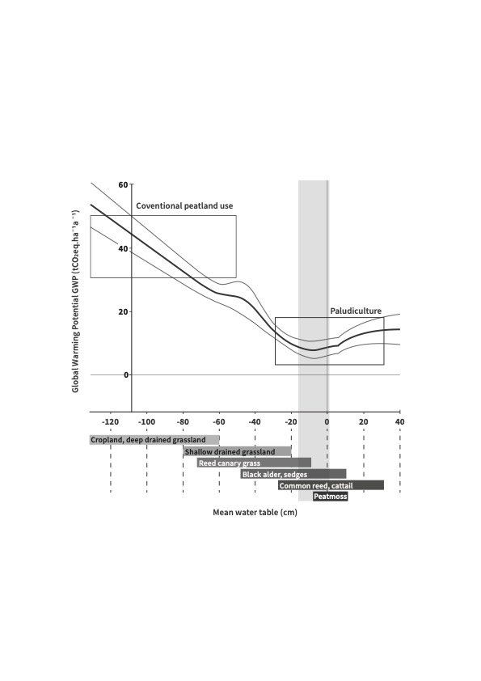

**Basic measures to reduce CO2 emissions from lowland drained peat**

* Raise the water level as far as possible*. This will reduce the amount of the peat that is available for breakdown to CO2 in the atmosphere. The idea level appears to be 10 to 20cm below the surface
* Use tillage-free management. Disturbing peat soil increases the aeration and surface area open for breakdown to CO2.
* Use crops that are harvestable without soil disturbance, or convert to permanent grassland.

*This may need consultation with neighbouring landowners, and is more economical if multiple landowners can work together for a larger area.

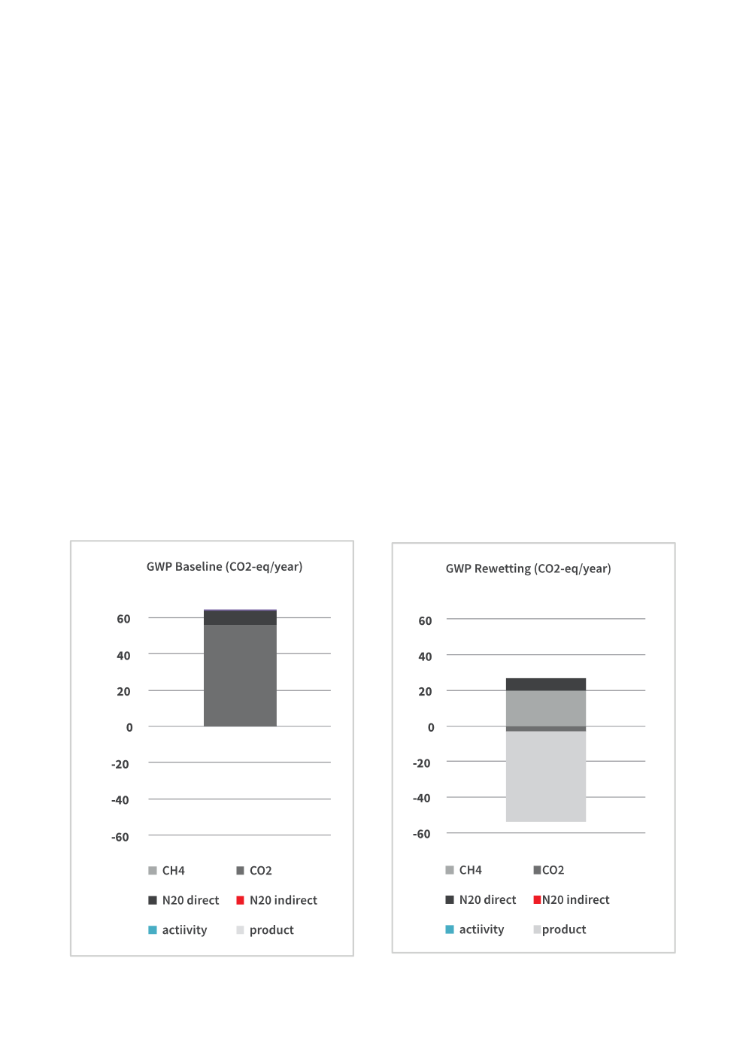**The Site Emissions Tool**

The Site Emissions Tool has been developed by Van Hall Laurenstein University of Applied Sciences in the Netherlands to support landowners and farmers to estimate the current emissions from their site. This can then be compared to emissions under a different management system. This is a first step towards estimating the potential for sale of Carbon Credits from a paludiculture or rewetting project.

The Site Emissions Tool, and the instructions for using it can be found at <https://www.nweurope.eu/projects/project-search/cconnects-carbon-connects/#tab-6>

**How do I know if I farm on peat soil?**

A peat soil has more than 50% organic material in the upper 80cm. If you do not have this information available, then further support for determining if your soil is peat can be found in the Natural England Soil Texture Guide available here.

<http://publications.naturalengland.org.uk/publication/32016>

**Further Information**

Paludiculture is a rapidly evolving practice. For further reading, we recommend visiting;

<https://moorwissen.de/paludiculture.html> <- General Information

<https://moorwissen.de/paludiculture-on-fens.html> <-For Fens

<https://moorwissen.de/paludiculture-on-bogs.html> <-For Bogs

**Calculation table**

Have a go at calculating your carbon emissions and saving that you could make. This is a very rough calculator, for more detailed calculations please use the Site Emissions Tool (SET) available at the link below.

[www.nweurope.eu/projects/project-search/cconnects-carbon-connects/#tab-6](http://www.nweurope.eu/projects/project-search/cconnects-carbon-connects/#tab-6)

|  |  |  |  |  |
| --- | --- | --- | --- | --- |
|  | **Current land use** | **CO2 Emissions** | **Future land use** | **Potential saving** |
| Plot 1 |  |  |  |  |
| Plot 2 |  |  |  |  |
| Plot 3 |  |  |  |  |
| Plot 4 |  |  |  |  |
| Plot 5 |  |  |  |  |
| Plot 6 |  |  |  |  |
| Plot 7 |  |  |  |  |
| **Total** |  |  |  |  |

**Data**

|  |  |
| --- | --- |
| **‘Traditional’ land use** | **Emissions/ ha** |
| Intensive cropping | 47 t/ha |
| Intensive pasture | 37 t/ha |
| Extensive pasture | 18 t/ha |

|  |  |
| --- | --- |
| **Wetland Crop** | **Emissions/ ha** |
| Sphagnum | 5 t/ha |
| Typha | 15 t/ha |
| Phragmites | 3 t/ha |
| Wet Grassland | 10 t/ha |

ss