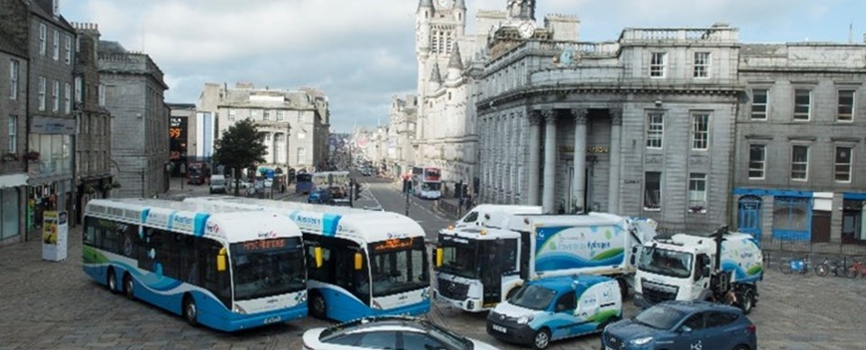

2023

Prepared by:

Claudia Cheng

Assisted by:

Bjørn Moen Ballo

Erik Russeltvedt

UiT The Arctic University of Norway

WP5 Hydrogen Supply Chain Mapping Report

Contents

1.0 Executive Summary 3

2.0 Introduction 4

3.0 Hydrogen Supply Chain map 6

4.0 Overall Outputs 10

4.1 Output 2: Number of entities engaged in cross-border research projects. 16

4.2 Output 3: Number of research institutions engaged in cross-border research projects. 19

4.3 Output 4: Number of entities who adopted new solutions by project end. 21

4.4 Output 5: Number of entities who were informed about new solutions by project end. 24

5.0 Recommendations for future supply chain growth 28

6.0 Glossary 29

**Table of Figures**

Figure 1: Hydrogen Supply Chain Map (Pale Blue Dot Energy, 2018) 6

Figure 2: Revised hydrogen supply chain map 7

Figure 3: Detailed hydrogen supply chain categories (part 1) 8

Figure 4: Detailed hydrogen supply chain categories (part 2) 9

Figure 5: Total number of entities engaged by country. 11

Figure 6: Number of unique entities engaged by type of engagement. 12

Figure 7: Number of entities engaged by hydrogen supply chain category. 14

Figure 8: Number of entities engaged under Support Services 15

Figure 9: Entities engaged in output 2 cross-border research project by country. 16

Figure 10: Number of entities engaged in cross-border research projects. 17

Figure 11: Number of entities engaged in cross-border research projects by hydrogen supply chain category. 18

Figure 12: Number of research institutions engaged in cross-border research projects. 19

Figure 13: Total number of research institutions engaged by country. 20

Figure 14: Breakdown of entities that adopted new solutions by country. 21

Figure 15: Number of entities who adopted new solutions by project end. 22

Figure 16: Number of entities who adopted new solutions by hydrogen chain category. 23

Figure 17: Number of entities who were informed about new solutions by project end. 24

Figure 18: Number of entities who were informed about new solutions by hydrogen supply chain category. 25

Figure 19: Type of support services group informed about new solutions. 26

Figure 20: Type of technology provider informed about new solutions. 27

# **1.0 Executive Summary**

The objective of the Hydrogen Transport Economy for the North Sea Region (HyTrEc2) project is to help stimulate the development of the hydrogen market in the North Sea Region (NSR). Its activities primarily focus on conducting vehicle trials with both retrofitted and new fuel cell electric vehicles (FCEVs), development of hydrogen refuelling facilities, creation of training modules on hydrogen transport, participating in conferences and events to promote hydrogen transport, and partnering with other actors to build up the supply chain.

The project was in operation from 2nd October 2016 to 10th Jun 2023 and coincided with the COVID-19 pandemic in 2020 and 2021. Despite the slowdown in activities, the project was successful in achieving all its output objectives. In total, an estimated 612 entities were engaged through HyTrEc2 activities and 86% are based in the regions where the partners are based: Germany, Netherlands, Norway, Sweden and the UK (Scotland and England). The biggest outreach is in Scotland and Netherlands, where the hydrogen vehicle trials took place by HyTrec2 Partners Province of Drenthe, City of Groningen, Aberdeenshire Council and Aberdeen City Council. Beyond the NSR, HyTrEc2 partners have also reached out to hydrogen entities from outside of the region, such as the rest of Europe, USA and Japan. This is in line with the growing trend of hydrogen-related activities in the region, as observed by all the partners.

Given the focus of the project, it is unsurprising that the supply chain is mostly concentrated on the downstream end, which is the end-user applications. To develop the FCEV market in the NSR, further engagement with upstream actors is recommended to overcome the notorious “chicken-and-egg” dilemma. Upstream actors include renewable energy producers, hydrogen producers, hydrogen storage and distribution suppliers. Further supply chain development may also benefit from future collaboration among the project partners, working together and streamlining the processes.

# **2.0 Introduction**

The HyTrec2 project is transnational project co-funded by the European Regional Development Fund under the Interreg VB North Sea Region Programme 2014-2020. The project started on 2nd October 2016 and ended on 10th June 2023. The kick off meeting took place in February 2017 in Aberdeen. The main objective for HyTrec2 project is to contribute to favourable conditions for the development and promotion of the NSR as a Centre for Excellence for the FCEV market.

The HyTrec2 project team is made up of 8 partners who are based in Germany, Netherlands, Norway, Sweden and the UK. All the partners have been active in the project since 2017 except for atene Kom, who replaced Eifi since 2020 (Table 1). There are a total of 5 work packages (WP) and the leader of the respective WP is shown in Table 1.

|  |  |  |  |
| --- | --- | --- | --- |
| Name of Partners | Years active | WP leader | Geographical base |
| Aberdeen City Council (ACC) | 2017-2023 | 1 & 2 | Aberdeen, Scotland |
| Centre of Excellence for Low Carbon and Fuel Technologies (CENEX) | 2017-2023 | 3 | Leicestershire, England |
| Research Institute of Sweden (RISE) | 2017-2023 | 4 | Gothenburg, Sweden |
| UiT The Arctic University of Tromsø (UiT) | 2017-2023 | 5 | Narvik, Norway |
| Provincie Drenthe | 2017-2023 |  | Drenthe, Netherlands |
| Gemeente Groningen | 2017-2023 |  | Groningen, Netherlands |
| Aberdeenshire Council | 2017-2023 |  | Aberdeenshire, Scotland |
| The Agency for Communications, Organisation and Management (atene Kom) | 2020-2023 |  | Berlin, Germany |
| Europaisches Institut fur Innovation (EiFi) (Inactive) | 2017-2020 |  | Osterholz-Scharmbeck, Germany |

The five WPs consist of project management (WP1), communication activities (WP2), vehicle trials (WP3), low-carbon hydrogen production, storage and distribution (WP4) and supply chain development and training (WP5). This report has been prepared as part of WP5, whose objective is to provide an overview of how the hydrogen supply chain has developed through HyTrec2 activities since the kick-off of the project in 2017 until June 2023.

At the beginning of the project in March 2018, Pale Blue Dot Energy (now Storegga), an energy consultancy firm, provided HyTrEc2 with a detailed hydrogen supply chain map for the purpose of assessing and developing the hydrogen supply chain engagement by HyTrEc2 partners in the NSR. In this report, the region is defined by the countries where the HyTrEc2 partners are based, that is Germany, Netherlands, Norway, Sweden and the UK. In addition, four ways of promoting the hydrogen supply chain growth were identified as follows:

1. growing existing regional hydrogen supply chain businesses
2. diversifying existing regional companies into hydrogen
3. bringing existing hydrogen players to the region
4. stimulating new hydrogen businesses in the region.

The HyTrEc2 project has established five output indicators for measuring its progress regularly throughout the project period:

* Output 1: Number of new and/ or improved green transport solutions adopted
* Output 2: Number of enterprises participating in cross-border, transnational or interregional research projects
* Output 3: Number of research institutions participating in cross-border, transnational or interregional research projects
* Output 4: Number of organizations/ enterprises adopting new solutions by project end
* Output 5: Number of organizations/ enterprises informed about new solutions by project end

This report aims to identify how the above-mentioned four ways have contributed to the outputs of the HyTrEc2 project and the development of the hydrogen supply chain based on a revised version of the hydrogen supply chain map provided by Pale Blue Dot Energy.

# **3.0 Hydrogen Supply Chain map**

Figure 1 shows the hydrogen supply chain map presented by Pale Blue Dot Energy, broken down into 6 different steps: Hydrogen production, transport of hydrogen, hydrogen storage, hydrogen end-use applications in the transport and non-transport sectors, as well as hydrogen support services.

Figure 1: Hydrogen Supply Chain Map (Pale Blue Dot Energy, 2018)

Given that hydrogen is an energy carrier, the development of its supply chain is dependent on other factors such as the source and distribution of energy to the hydrogen production site. To cover the entirety of the hydrogen supply chain, this report considers it important to include entities that are involved in producing energy (01), supplying the feedstock for hydrogen production (02), providing the infrastructure for energy distribution (03). The category, “10 Technology provider” has been added to distinguish the entities involved in providing hydrogen-related technologies from those that provide other support services like engineering, legal and financial services. This gives rise to a 10-category hydrogen supply chain, as shown in Figure 2.

Figure 2: Revised hydrogen supply chain map

Each category of the hydrogen supply chain can be broken down further to show the different product and services options as presented in Figure 3 and 4.

Figure 3: Detailed hydrogen supply chain categories (part 1)

Figure 4: Detailed hydrogen supply chain categories (part 2)

# **4.0 Overall Outputs**

Overall, HyTrEc2 project has achieved better results than its targets. The indicators for output number 2 to 5 monitor the number of entities engaged by HyTrEc2 partners and these indicators will be the focus of this report.

Table 1: Total achievement on output of the project

|  |  |  |  |
| --- | --- | --- | --- |
| Output number | Output Description | Output target | Total achievement |
| 1 | Number of new and/or improved green transport solutions adopted | 8 | 11 |
| 2 | Number of enterprises participating in cross-border, transnational or interregional research projects | 27 | 67 |
| 3 | Number of research institutions participating in cross-border, transnational or interregional research projects | 12 | 35 |
| 4 | Number of organizations/ enterprises adopting new solutions by project end | 55 | 55 |
| 5 | Number of organizations/ enterprises informed about new solutions by project end | 250 | 765 |

Note: The total achievement numbers differ slightly from the rest of the report due to missing information on entities

Since the start of the project, HyTrEc2 partners have engaged with a total of 612 unique entities through its activities, of which 26% are based in Scotland, 18% in Netherlands, 14% in England, 12% in Sweden, 10% in Germany and 6% in Norway. That means, 86% of the entities were based in the region where HyTrEc2 partners are also based. For some of the partners, the growth in hydrogen-related activities was beyond their expectations, while for most, all have observed a general increase in hydrogen-related activities in the region during the HyTrEc2 project.

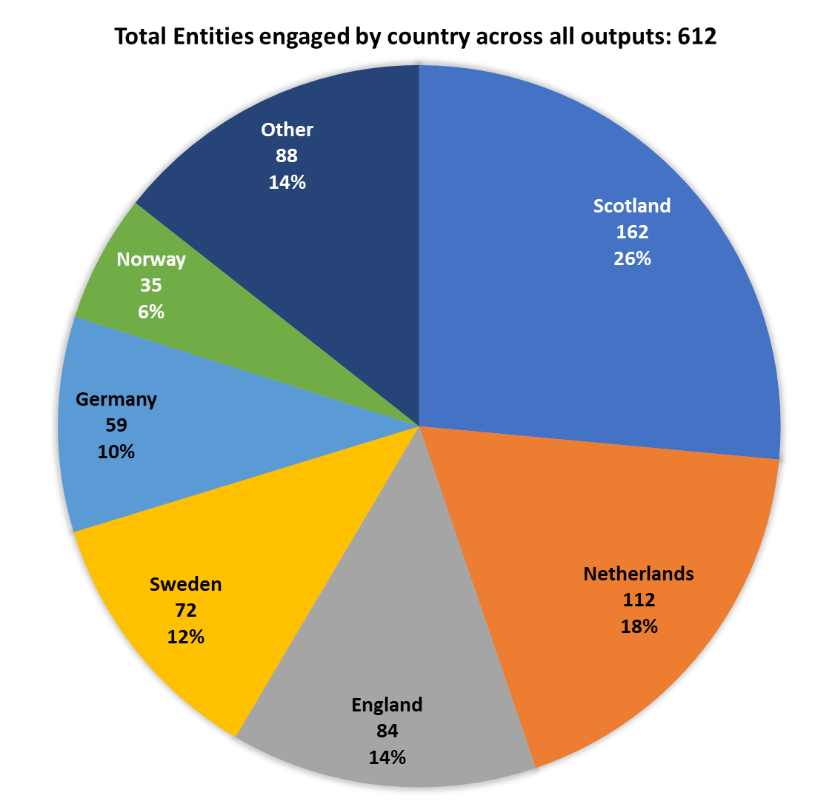

Figure 5: Total number of entities engaged by country.

Figure 6 shows the total number of entities that HyTrEc2 have engaged through various strategies. The total number differs slightly from in Figure 5, due to the change of status for entities from one year to another, such as those who were initially not active in the hydrogen supply chain, but later adopted hydrogen solutions. In the first three years of the project, between 2017 and 2019, the average number of unique entities engaged was around 139, but the number dropped drastically during 2020 and 2021 due to the COVID-19 pandemic period. In the first 2 years (2017 and 2018), most entities engaged were existing businesses or organisations that were not active in the hydrogen market at the point of contact. From 2019 onwards, there were more existing regional hydrogen businesses engaged through the HyTrEc2 activities than non-hydrogen entities. Some of the existing regional hydrogen entities include non-hydrogen entities that were previously engaged by HyTrEc2 partners. The small number of new hydrogen businesses in the region engaged by HyTrEc2 partners could indicate that many of the entities in the hydrogen supply chain were existing entities rather than new ones.

Figure 6: Number of unique entities engaged by type of engagement.

As Figure 7 shows, most of the entities engaged by HyTrEc2 partners fall under the “09 Support Services” and “10 Technology providers”. This may be attributed to the nascent stage of hydrogen market. The number of entities involved in “01 Energy source”, “03 Energy Infrastructure”, “04 Hydrogen Production”, “07 Hydrogen Infrastructure” and “08 End-use applications” were evenly engaged by HyTrEc2 partners, whereas entities involved in “02 Feedstock”, “05 Hydrogen Storage” and “Hydrogen Transport” were the least engaged. Entities in “02 Feedstock” include water suppliers in the case of green hydrogen production and natural gas suppliers in the case of blue hydrogen production.

The lack of engagement with entities involved in the two latter categories may be attributed to the focus on small-scale local production of hydrogen at the site of consumption, thereby eliminating the need for hydrogen storage and transport. It is also possible that given the nascent phase of the hydrogen market, this reflects a chicken-and-egg dilemma where demand for hydrogen is low because of the missing infrastructure and infrastructure is not built because hydrogen demand is low. Note that the total number of entities differs slightly from that of Figure 5 due to entities belonging to multiple categories at different time periods.

Figure 7: Number of entities engaged by hydrogen supply chain category.

Among the entities under the Support Services category, entities involved in government policies and regulations (20%), consultancy, and project management (19%), as well as awareness, education and training (13%) represent the biggest groups (Figure 8). The latter reflects one of the core activities engaged by HyTrEc2, which is providing training courses on hydrogen transport and promoting them at governmental organisations. In addition, HyTrEc2 partners have received most enquiries from other local authorities looking to learn, businesses looking to move into hydrogen and suppliers who are already providing hydrogen products.

Figure 8: Number of entities engaged under Support Services

## **4.1 Output 2: Number of enterprises engaged in cross-border research projects.**

The number of entities which HyTrEc2 partners have engaged in cross-border research projects from 2017 to 2023 totalled 68. Most of them are based in Netherlands (34%), Scotland (19%) and England (13%). These are countries where most pilot/demonstration projects take place.

Figure 9: Entities engaged in output 2 cross-border research project by country.

44% of the organisations are based in the region and have existing activities related to hydrogen, while 37% were non-hydrogen players based in the region. 19% are existing hydrogen entities from outside the region. There was no collaboration with newly created hydrogen organisations from the region.

Figure 10: Number of entities engaged in cross-border research projects.

Most of the entities engaged in cross-border research projects are technology providers (31%), support services providers (29%), end-users (13%) and hydrogen infrastructure providers (10%). This reflects one of the core activities of HyTrEc2, which is to improve operational efficiency of fuel-cell driven vehicles and conduction hydrogen trials with potential end-users.

Figure 11: Number of entities engaged in cross-border research projects by hydrogen supply chain category.

## **4.2 Output 3: Number of research institutions engaged in cross-border research projects.**

HyTrEc2 partners have engaged a total of 33 research institutions during the project. 42% of them are organisations based in the region and have existing activities related to hydrogen, while 33% of the entities were existing organisations in the region and exploring the hydrogen market and 21% are existing hydrogen entities from outside the region.

Figure 12: Number of research institutions engaged in cross-border research projects.

Out of 33 research institutions engaged, 28 are from the region and 5 from outside the region. Netherlands and Sweden accounts for the greatest number of research institutions engaged (8 respectively), followed Scotland (5).

Figure 13: Total number of research institutions engaged by country.

## **4.3 Output 4: Number of organisations who adopted new solutions by project end.**

The total number of entities that were engaged by HyTrEc2 partners and adopted new solutions by the end of the project stands at 54. 42% of them are based in Scotland, followed by Netherlands (17%) and Norway (20%).

Figure 14: Breakdown of entities that adopted new solutions by country.

49% of them are existing hydrogen entities based in the region, while another 44% were non-hydrogen actors based in the region. Only 7% are hydrogen actors from outside the region. Most of the adoption happened in 2017, which were linked to the Aberdeen City Hydrogen Energy Storage (ACHES)/ Toyota Launch event, the development of hydrogen training modules, the launch of Hyundai H2 cars, the hydrogen infrastructure app development, Toyota Mirai trails and the retrofitting of Nissan EnV200 van.

Figure 15: Number of entities who adopted new solutions by project end.

Majority of the entities that adopted new solutions were for end-use applications (30%), support services (28%) and hydrogen infrastructure providers (14%). The end-use applications include some hydrogen cars (Scotland), a hydrogen van (Scotland), a hydrogen garbage truck (Netherlands), and a high-speed boat (Norway). Support services providers consist of entities that adopted new training modules and hydrogen infrastructure app, trialled hydrogen vehicles and installed a hydrogen refuelling station.

Figure 16: Number of entities who adopted new solutions by hydrogen chain category.

## **4.4 Output 5: Number of organisations who were informed about new solutions by project end.**

43% of the entities who were informed about new solutions related to hydrogen were existing organisations based in the region and were already involved in hydrogen activities at the point of contact. They make up the biggest group from 2019 onwards. Prior to 2019, existing organisations based in the region but not involved in hydrogen activities formed the biggest group informed by HyTrEc2 partners. They represent 41% of the total entities informed of new solutions. 14% of the entities informed were hydrogen players from outside of the region.

Figure 17: Number of entities who were informed about new solutions by project end.

The nature of entities who were informed by HyTrEc2 partners about the new solutions are mostly from the support services group (59%) and technology providers (17%).

Figure 18: Number of entities who were informed about new solutions by hydrogen supply chain category.

Under the support services group, government bodies (22%), consultation firms (19%) and entities involved in promoting awareness, providing education and training services (11%) make up the biggest groups.

Figure 19: Type of support services group informed about new solutions.

Among the technology providers who were informed about new solutions by HyTrEc2 partners, majority of them are fuel cell and hydrogen specialists (47%), which grew steadily from 2017 to 2020. Other component suppliers make up the next biggest group, which include a wide range of components, from precision machined components, thermal storage solution providers, construction equipment suppliers, mobile power stations, ground power unit to electrolyser membranes and valves.

Figure 20: Type of technology provider informed about new solutions.

# **5.0 Recommendations for future supply chain growth**

Through the activities of the HyTrEc2 project, the hydrogen supply chain in the NSR has expanded tremendously, especially around the downstream end. As the demand for hydrogen grows, there will be a need to ensure that the supply chain on the upstream develops in parallel to overcome the “chicken-and-egg” dilemma, in which end-users are hesitant to invest in the technology before more infrastructure is available and hydrogen producers are hesitant to scale up before demand for hydrogen is sufficiently high.

The supply chain network in each country is mostly developed by the project partner based in that country. Further development of the supply chain may benefit from future collaboration among the project partners, working together and streamlining the processes.

# **6.0 Glossary**

|  |  |
| --- | --- |
| ALK | Alkaline |
| ATR | Auto-thermal Reforming |
| CCS | Carbon Capture and Storage |
| FCEV | Fuel Cell Electric Vehicle |
| H2 | Hydrogen |
| HRS | Hydrogen Refuelling Station |
| HSE | Health, Safety, Environment |
| NSR | North Sea Region |
| PEM | Proton exchange membrane |