|  |  |  |
| --- | --- | --- |
| \\acc.gov.uk\data\CHI\Econ\Docs1\PROJECTS TEAM\H2\PROJECTS\HyTrEc 2\LEAD project\PROJECT MANAGEMENT\WP2 Communications\Logos etc\New Hytrec 2\HyTrEc2-02-A-colour.png |  |  |
| \\acc.gov.uk\data\CHI\Econ\Docs1\PROJECTS TEAM\H2\PROJECTS\HyTrEc 2\LEAD project\PROJECT MANAGEMENT\WP2 Communications\Logos etc\HyTrEc_2_logo.jpg | \\acc.gov.uk\data\CHI\Econ\Docs1\PROJECTS TEAM\H2\PROJECTS\HyTrEc 2\LEAD project\PROJECT MANAGEMENT\WP2 Communications\Logos etc\Green Transport Icon.jpg |

**HyTrEc2 Response to the EU Hydrogen Strategy Roadmap**

**Background**

The Interreg NSR HyTrEc2 (Hydrogen Transport Economy for the North Sea Region2) project welcomes the opportunity to provide feedback on the roadmap towards an EU Hydrogen Strategy. We believe this is a positive step towards Europe embracing hydrogen as a transport, energy, industrial and heat vector. The HyTrEc2 project is co-funded by the North Sea Region Programme 2014-2020. Our Partners are: Aberdeen City Council, Aberdeenshire Council and Cenex (UK), Provincie Drenthe and Geemente Groningen (The Netherlands), the European Institute for Innovation (Germany), The Artic University of Norway and Research Institutes of Sweden.

**Executive Summary**

* To achieve net zero by 2050 Europe needs to construct renewable energy generation storage and distribution for hydrogen applications
* Additional measures are required to mitigate the impact of climate change
* Green renewable hydrogen offers a zero carbon alternative to Hydrogen Carbon Capture & Storage projects (ie blue hydrogen) and can stimulate an energy transition that HyTrEc2 Partners in the Northern Netherlands (known as the Northern Netherlands Hydrogen Valley) and North East Scotland (known as the Aberdeen Hydrogen Hub) are currently working towards.
* Hydrogen is an appropriate solution for longer distance, larger vehicles requiring quick refuelling over and above other available zero carbon technologies. It also has advantages for areas with constrained land space and grid electricity upgrade restrictions, making it suitable for City, as well as rural, applications.
* Europe requires a hydrogen refuelling station network to foster the uptake of hydrogen vehicles. These should be focused on corridors that connect hydrogen regions throughout Europe to foster and cascade uptake of hydrogen in these regions (and their intermediate areas) and facilitate the decarbonisation of the road freight industry.
* The proposed hydrogen refuelling network should expand to include other modes of transport. Ports and rail depots must also be included.
* Funding should be centred around delivering the above ambitions.

**Introduction**

The HyTrEc2 project brings together Partners from the UK, Germany, The Netherlands, Sweden and Norway to support the use of hydrogen in the transport and energy sectors. Project Partners are aiming to produce, store and distribute renewably produced hydrogen for refuelling a variety of innovative hydrogen vehicles, including vans and waste trucks. By offering hydrogen training and skills development alongside practical sessions for businesses interested in entering the hydrogen supply chain, the project is stimulating the hydrogen economy across the North Sea Region.

**Main Response**

1. Transport remains one of the most stubborn areas for reducing climate emissions. 92% of transport in Europe is oil based[[1]](#footnote-1). Over the past five years use of renewable energy sources in transport has increased from 6% in 2013 to 8.2% in 2018. This is slow progress compared to other sectors (32% electricity, 21% heating and cooling in 2018) and if we are genuine about reducing emissions from transport for carbon, air quality, environmental and health reasons, in accordance with various EU policy declarations, then this needs to be addressed as a matter of urgency.
2. It is now fairly widely acknowledged that any net zero carbon energy system will require a significant amount of hydrogen. Hydrogen has the potential to interlink or “sector-couple” between different areas of the energy system. Renewable energy production can be stored as hydrogen and then used for transport, industrial and heat purposes. However, the long term potential of hydrogen can only be realised if Europe bravely embraces this technology, allows for industrial regulatory learning and assists with bringing costs down to the point where hydrogen solutions offer an equivalent, or better option, in comparison to today’s fossil fuelled incumbents.
3. Hydrogen’s versatility and per kWh cost for long term energy storage are extremely promising, particularly when compared to other technologies, see figure 1 below. There is significant potential for using hydrogen storage during periods of wind curtailment with the added benefit that the hydrogen produced can be used in transport, as well as in the energy grid, thereby achieving sector coupling. Europe has existing expertise in the underground storage of hydrogen, and a skilled North Sea workforce facing an uncertain future as fossil fuels are phased out between now and 2050. Combined with abundant offshore wind potential, Europe is well placed to develop world leading expertise as the commercialisation of hydrogen increases. There are significant export opportunities for use of green hydrogen across the world for deindustrialisation purposes and Europe could become one of the early adopters/ first movers in offshore hydrogen production.

**Figure 1:** Energy Storage Technologies (SGN, 2019)



1. Internationally there is over 20 years’ experience in providing hydrogen and hydrogen-gas blends to generate power in industrial settings. Every industrialized nation in the world has an extensive network of experts in the industrial use of hydrogen; for the manufacture of ammonia, fertilizer, refining fossil fuels, glass manufacture and host of other industrial application too numerous to mention. Encouraging cross fertilization between these industrial hydrogen users and the nascent hydrogen sectors (such as transport and energy storage) is an area that has yet to fully develop. The case for hydrogen for home heating has yet to be made, however initial signs are very promising. Some, if not all, domestic natural gas use can be replaced by hydrogen.
2. **Hydrogen generation at scale** is arguably the lowest-cost zero-emission solution to this energy demand by 2050. The HyTrEc2 Partnership has established that to meet the predicted demand gap of 669 TWh in the UK, approximately 570 such electrolysers would need to be commissioned every year from 2020 to 2050. Each electrolyser would also require the construction of suitable renewable energy (with 30 MW peak power output for each 10 MW electrolyser: approximately the equivalent of five wind turbines.) factoring reasonable levels of technology improvement can reduce the estimated energy demand slightly. **To meet the combined direct electrification and hydrogen generation demand by 2050 in the UK, renewable energy generation equivalent to 5,000 wind turbines must be constructed every year between now and 2050.** There will be a similar picture across other European countries.
3. Immediate action is required to mitigate climate change. Europe must further legislate to encourage the adoption of low and zero emission technologies in all sectors. **Legislation is essential to redress market failures that prevent the uptake of more energy efficient and less polluting technologies**. There is growing evidence that hydrogen has a role to play in rail and marine applications. The inclusion of ports and rail refuelling depots can expand the hydrogen economy to modes of transport beyond road freight. Central government and EU funding for these locations can be contingent on the supply of hydrogen to the wider community. So called ‘through the wall’ public refuelling systems can expand the HRS network without compromising site safety at ports and rail marshalling yards.
4. As a consortium, the HyTrEc2 partnership are successfully demonstrating the use of hydrogen to power vehicles. Vehicle types include small vans, luxury saloon cars, buses, road sweepers and rubbish collection trucks. Real world energy consumption data has been benchmarked against ‘green’ (renewably generated), “blue” (steam methane reformed natural gas with carbon capture) and “grey” (fossil fuel generated) hydrogen. Well to wheel (WTW) emission estimates indicate that hydrogen fuel cell vehicles powered by grey (fossil fuel derived) hydrogen can still offer up to 60% saving in total CO2e emissions compared to an equivalent diesel vehicle. Even without carbon capture and storage, fossil derived hydrogen has the potential to eliminate the majority transport CO2e emissions. **Data from HyTrEc2 provides very strong evidence** **hydrogen fuel cell vehicles are inherently more efficient than conventional internal combustion engine vehicles**. Steam methane reformation (SMR) of fossil gas into hydrogen, when used in a fuel cell vehicle, still achieves a 40% to 60% reduction in emitted CO2e per mile driven. **However, green renewably produced hydrogen has zero emissions and this option allows for complete decarbonisation of transport applications. It should therefore be recognised as the primary policy delivery model of a decarbonised transport network with associated funding and promotion.**

**Figure 2:** Well to wheel savings at HyTrEc2 Partner Refuelling Station using various types of electricity to generate hydrogen

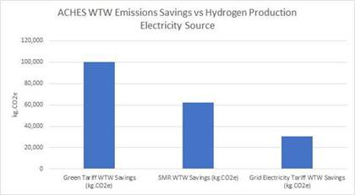

1. As well as needing to produce hydrogen at scale to reduce costs, hydrogen vehicle technology maturity and costs remain a significant barrier to adoption. Vehicle deployment under the HyTrEc2 project has only been possible with EU funding. Vehicle cost premiums are expected to reduce over time as global production volumes and growing demand for hydrogen vehicles increases, which will unlock economies of scale for components and for production processes. However, decreasing levels of vehicle subsidy could be provided to support vehicle sales as sales costs reduce over time. Under the HyTrEc2 partnership Aberdeen City Council and Aberdeenshire Council have worked on Joint Vehicle Procurements to achieve small financial savings. This has occurred on a larger scale with FCH JU JIVE and their large bus procurements and such delivery models are to be commended. Similar initiatives could be launched for hydrogen waste trucks, road sweepers and other public sector vehicles to encourage vehicle manufacturers to enter the market (example of Switzerland order of 1,600 HGVs by various fleets around the country).
2. HyTrEc2 Partners have noted that there seems to be a level of unnecessary competition between battery electric vehicles (BEVs) and hydrogen vehicles. The HyTrEc2 partnership believes there is a case for both technologies, and both will need to be embraced in different circumstances. Our studies have demonstrated that battery electric vehicles (BEVs) are suitable for a number of applications for Partner organisations’ fleets, particularly when operating over short distances in smaller vehicles with time to recharge. However, a significant number of vehicles also make mission critical journeys that exceed BEV range, particularly in rural areas, and in towns where electricity supply is limited and major grid upgrades are required (footprint of recharging stations vs. number of vehicles). However, hydrogen also has advantages for areas with constrained land space and grid electricity upgrade restrictions, making it suitable for City, as well as rural, applications. Emergency response vehicles such as police cars, ambulances, and utility repair vans are particularly difficult to electrify. Geographically large regions such as Aberdeenshire, Narvik and Drenthe are especially impacted. It is equally clear that specialist vehicles such as road sweepers, intercity buses, garbage collection vehicles and gritters require a solution other than battery technology. For HGV use, single shift short journey trucks can be electrified with battery technology in smaller vehicles. However, heavy duty freight operating long distances or multiple shifts are unlikely to be well suited to battery only propulsion (anything over 100km/ day). A significant number of larger vehicles will require hydrogen propulsion. Europe does not need to wait for zero emission hydrogen to become available before constructing hydrogen refuelling station (HRS) infrastructure.
3. There has long been debate on how the hydrogen transport economy should be fostered. The classic “chicken and egg” of vehicles Vs HRS infrastructure has at long last been answered. **Hydrogen vehicles cannot be sold until HRSs are in place.** Europe needs to provide a network of publicly funded HRS suitable for both passenger vehicles and HGVs. Provision of preferably renewably produced hydrogen to these networks will encourage vehicle OEMs to make hydrogen fuel cell vehicles suitable for the European marketplace. Collaboration with OEMs on **unified specifications hydrogen freight transports is vital to the economy.** Distribution should be focused on TEN-T corridors and connecting the hydrogen regions throughout Europe to foster and cascade uptake of hydrogen and facilitate the decarbonization of the road freight industry in these regions and their intermediate areas. Appropriate funding needs to be available to facilitate this. The development of refuelling apps such as H2.live (<https://h2.live/en>), developed in partnership with H2 Mobility, Germany and HyTrEc2 Partner, the EIfI need to be promoted alongside this. A model for green h2 distribution is suggested below (Aberdeen Hydrogen Hub, 2019). While producing hydrogen via electrolysis to refuel on site is an option, especially in more remote locations, the most economic and commercially viable model is that hydrogen is produced at scale from wind or solar and then distributed to refuelling points (preferably by hydrogen tube trailer) until enough demand is generated in an area to allow for bespoke refuelling solutions.

**Figure 3:** H2 Renewable Refuelling Model

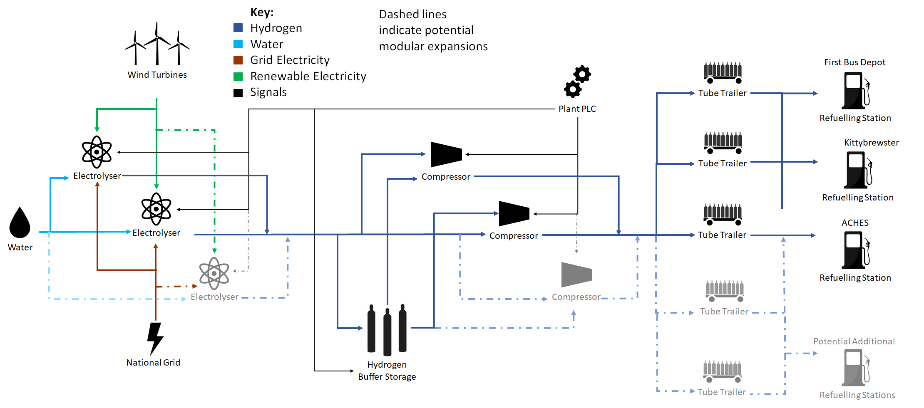

1. Funding has been essential for progression of the activities detailed above. Any Strategy requires an associated budget that is consummate with the scale of ambition required i.e. delivering an energy transition and zero carbon economy and should focus on regions that are committed to hydrogen delivery. The HyTrEc2 partnership are very supportive of an EU Hydrogen Strategy based around renewably produced hydrogen. We are also happy to share any results with the Commission on how hydrogen has been applied practically for use in vehicles, green hydrogen production, supply chain work and training. Further information can also be found at: <https://northsearegion.eu/hytrec2>.

1. <https://ec.europa.eu/eurostat/tgm/table.do?tab=table&plugin=1&language=en&pcode=sdg_07_40> Percentage of “renewable energy sources in transport” (2018) [↑](#footnote-ref-1)